Section 12
Supervision of School Health Services
Supervised on |  | Supervisor
Date: | Name:
Time Started: am/pm | Designation:
Part 1
PHI Office Supervision
1. General information
1.1. RDHS area
1.2. MOH area
1.3. Name of the local authority (Pradeshiya
Sabha/Municipality area/Urban Council)
1.4. PHI area
1.5. Name of the PHI
1.6. Date appointed to this station
1.7. Date of first appointment
2. Transport facilities
2.1 Available | Yes | Personal | Departmental
2.1 Available | No | Date obtained
2.2. Is it in working condition (if applicable) | Yes | No
3. Uniform (dressed according to circular) | Yes | No
Reason/Explanation, if ‘No’:

 |  | 4. Schools in the PHI area
 |  | 4.1 No. of Schools | <200 |  |  |  | Government |  |  |  |  |  | Private
 |  | 4.1 No. of Schools | >200
 |  | 4.2 No. of Pre‐Schools |  |  |  |  | Government |  |  |  |  |  | Private
 | 4.3 School Profile |  |  |  |  | No. of schools |  | No. of students | Target (for Schools with >200 Students)
 |  |  |  |  |  |  |  |  | Grade 1 |  |  | Grade 4 |  | Grade 7 |  |  | Grade 10
 | 4.3.1 Government |  |  | < 200
 |  |  |  | > 200
 | 4.3.2 Private |  |  | < 200
 |  |  |  | > 200
 | 4.3.3 International (Private /International schools) |  |  | < 200
 |  |  |  | > 200
 | 4.3.4 Piriven |  |  | < 200
 |  |  |  | > 200
5. Separate file for each school (Maintained for current year) |  |  |  |  |  |  |  |  |  |  | Yes |  |  |  | No
Reason/Explanation, if ‘NO’:
 |  |  |  |  |  |  |  |  |  |  | Yes |  |  |  | No
5.1 School Health Survey
5.2 Defect Sheet
5.3 Health Promoting School evaluation formats*
- Use the Evaluation Format given in page 148 in the Guidelines for School Health
Promotion Programme

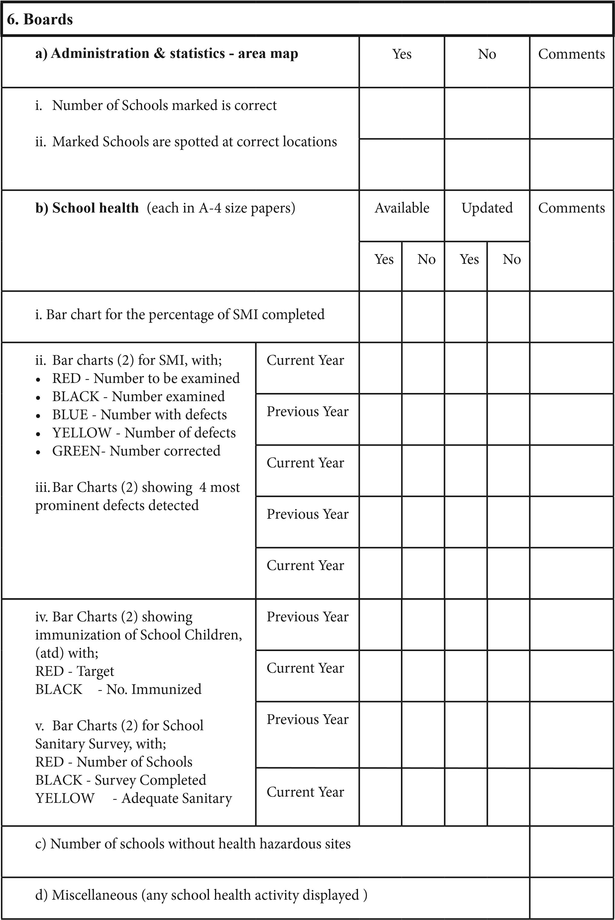

7. Quarterly advance programme (H‐1016) |  | Previous year |  |  | Current year |  | Remarks
- Forwarded to MOH before;  − for 1st Quarter : December 25th  − for 2nd Quarter: March 25th  − for 3rd Quarter : June 25th  − for 4th Quarter : September 25th  - Aproved copies filed at the office of the PHI  − for 1st Quarter  − for 2nd Quarter  − for 3rd Quarter  − for 4th Quarter |  | Yes | No |  | Yes | No
c) Planned according to Monthly Advance Programme
d) Implemented according to Monthly Advance Programme
8. Annual advance programme (H‐1016) | Yes |  |  | No |  | Remarks
8.1.1 Forwarded to MOH before October bbbbbb25th of previous year
8.1.2 Approved copy filed at the office of the
bbbbbbPHI

9. Summary of data (H‐1016),  After completion of the Previous Year’s 2nd  Quarter Advance Programme; |  |  | Yes |  | No | Remarks
9.1.1 Forwarded to MOH
9.1.2 Copy Forwarded to MO(MCH)
10. School sanitary surveys | School |  |  | Informed higher authorities for the  improvement
10. School sanitary surveys | No. | %
10.1 Total Surveys done during last/ current bbbbyear
10.1.1 Surveys done in 1st Quarter of current year¹
10.2 Schools without any sanitation facility²
10.3 Schools with inadequate sanitation facility²
10.3.1 Unavailability of a mechanism for cleaning
10.3.2 Unavailability of water supply to the toilet
10.4 Schools without drinking water
facilities
10.5 Schools without adequate water for washing
10.6 Schools with unprotected wells
10.7 Schools with unhealthy foods & drinks sold within the school premises
10.8 Schools with Improper garbage disposal/waste management
10.9 Schools with any health hazards

11. Notes on S.M.I. (check for past 3 months) |  |  |  |  |  |  |  | Available |  |  |  |  |  |  |  |  |  |  |  |  |  |  |  |  |  |  |  | Available
 |  |  |  |  |  |  |  | Yes |  |  |  |  | No |  |  |  |  |  |  |  |  |  |  |  |  |  |  | Yes |  |  |  |  |  | No
11.1 Pocket Note Book |  |  |  |  |  |  |  |  |  |  |  |  |  |  |  |  | Maintained up‐to date
11.2 Summary of Activities |  |  |  |  |  |  |  |  |  |  |  |  |  |  |  |  | Maintained up‐to date
11.3 Monthly Statement (H‐1014) |  |  |  |  |  |  |  |  |  |  |  |  |  |  |  |  | Maintained up‐to date
11.4 Immunization Registers |  |  |  |  |  |  |  |  |  |  |  |  |  |  |  |  | Maintained up‐to date
12. Defect type |  |  |  |  |  |  |  | School 1 |  |  |  |  |  |  |  |  |  |  |  |  |  |  | School 2
 |  |  |  |  |  |  |  | Identified |  |  |  |  |  |  |  | Corrected |  |  |  |  |  |  | Identified |  |  |  |  |  |  |  | Corrected
 |  |  |  |  |  |  |  | No. |  |  |  | % |  |  |  | No. |  |  | % |  |  |  | No. |  |  | % |  |  |  |  | No. |  |  |  | %
a) Visual Defects
b) Hearing Defects
c) Heart Diseases
13. Follow‐up visits made for School Medical Inspection (out of SMI done within last six months, randomly select defect sheets of 2 schools and compare it with monthly Return)
 |  |  | School 1 |  |  |  |  |  |  |  |  |  |  |  |  |  |  | School 2
 |  |  | Defect sheet |  |  | Monthly return |  |  |  |  |  |  |  |  |  |  |  | Defect sheet |  |  |  |  |  |  |  |  | Monthly return
 |  |  | Heart  Disease | Vision | Hearing | Heart  Disease |  |  |  |  | Vision |  |  | Hearing |  |  |  | Heart  Disease |  |  | Vision |  |  |  | Hearing |  | Heart  Disease |  |  |  |  | Vision |  |  |  | Hearing
No. of defects
No.
Followed
14. Cross-checked with defects in |  |  |  |  |  |  | School 1 |  |  |  |  |  |  |  |  |  |  |  |  |  |  | School 2
 |  |  |  |  |  |  | Defect Sheet |  |  |  |  |  |  |  | Monthly return  (H‐1014) |  |  |  |  |  |  | Defect sheet |  |  |  |  |  |  |  | Monthly return  (H‐1014)
Total number of children with defects
Total number of defects
 | 15. Submission of H‐1014 to  M.O.H. (During Last 3 months) |  |  |  |  |  |  |  | Date of submission |  |  |  |  |  |  |  |  |  |  |  |  |  |  | Timely submission
 |  |  |  |  |  |  |  |  |  |  |  |  |  |  |  |  |  |  |  |  |  |  |  | Yes |  |  |  |  |  |  |  |  | No
 | 15.1 1st Month
 | 15.2 2nd Month
 | 15.3 3rd Month
 |  | 16. Status of SMI activities (up to last quarter of the Current Year)
Type of  School |  | Detail |  |  |  |  |  |  |  | Number |  |  |  |  |  |  |  |  |  | % |  |  |  |  |  |  |  |  | Any remarks
 |  | Schools to be completed
 |  | Schools screened by PHI |  |  |  |  |  |  |  |  |  |  |  |  |  |  |  |  |  | %
 |  | Schools completed SMI |  |  |  |  |  |  |  |  |  |  |  |  |  |  |  |  |  | %
 |  | Children to be examined
 |  | Children examined |  |  |  |  |  |  |  |  |  |  |  |  |  |  |  |  |  | %
<200 |  | Schools completed Immunization |  |  |  |  |  |  |  |  |  |  |  |  |  |  |  |  |  | %
 |  | School commenced deworming |  |  |  |  |  |  |  |  |  |  |  |  |  |  |  |  |  | %
 |  | Schools commenced weekly Iron‐folate supplementation |  |  |  |  |  |  |  |  |  |  |  |  |  |  |  |  |  | %
>200 |  | Schools to be completed |  |  |  |  |  |  |  |  |  |  |  |  |  |  |  |  |  | %
 |  | Schools screened by PHI |  |  |  |  |  |  |  |  |  |  |  |  |  |  |  |  |  | %
 |  | Schools completed SMI |  |  |  |  |  |  |  |  |  |  |  |  |  |  |  |  |  | %
 |  | Children to be examined
 |  | Children examined |  |  |  |  |  |  |  |  |  |  |  |  |  |  |  |  |  | %
 |  | Schools completed immunization |  |  |  |  |  |  |  |  |  |  |  |  |  |  |  |  |  | %
 |  | Schools commenced deworming |  |  |  |  |  |  |  |  |  |  |  |  |  |  |  |  |  | %
 |  | Schools commenced Ironfolate supplementation |  |  |  |  |  |  |  |  |  |  |  |  |  |  |  |  |  | %
- Categorized by Total Points (>60 points) obtained according to the marking scheme of the ‘School
Health Promotion Programme’ (Ministry of Education, Cir. No. ED 1/21/1/2/2‐2007/21) or Pg. 148 of School Health Guide

17.Immunization & other* micronutrient coverage | Targeted  Number | Number protected  (at any time) | %  Covered | Reported AEFI  (specify effect/s)
17.1 DT/OPV**
17.2 aTd
17.3 Other vaccines
HPV 1
HPV 2
MMR/MR
17.4 Vitamin ‐ A
17.5 Weekly Iron Folate Cycle com-
menced
17.6 Worm treatment
- Check with H ‐ 1014 for supervision
 | 16. Summary of S.M.I. (during Last Year) | Number | % | Any remarks
 | 16.1 Total number of children with defects
 | 16.2 Total defects/problems identified
 | 16.3 Referred defects/problems
 | 16.3.1. Referrals followed‐up
** 21.1 DT/OPV ‐ Number protected means children who have received the vaccine in the field + Number received in the school
18. Health promoting activities  (during Last quarter) |  | Number |  | % |  | Any remarks / action taken
18.1 Total No. of schools in PHI’s area
18.2 Health Promoting Schools*(as of indicators for HP Schools)
18.2.1 GOLD > 80
18.2.2 SILVER 70-79
18.2.3 BRONZE 60 - 69
18.3. Evidence available for HP/HE activities done |  | Yes |  | No
18.4. Newly established Health Promoting Schools during the last quarter (as of monthly statement/HP
Register
18.5. Participated for school health advisory committees
(cross-check with the pocket notebook)
18.6. No. of school canteens
18.7. No. of school canteens H‐800 classified
18.8. No. of schools with mid‐day meal programme conducted
18.9. No. of schools with mid‐day meal programme conducted where H‐800 classified
19. Health education/ promotion activities  (during Last Year) | % |  | Based on  H‐1014 |  | Cross-check with Diary,  Pocket Note Book and Comment
19.1 Reproductive Health Programmes *
19.2 Nutrition Programmes **
19.3 Life skills Programmes ***
19.4 Communicable Diseases Programmes
19.5 Non‐Communicable Diseases Programmes
19.6 Programmes for non-school-going adolescents
19.7 Other Programmes
19.1 No. of Students participated in RH programmes * No. of Students in Grade 8
19.2 No. of Students participated in Nutrition programmes ** No. of Students in Grade 6‐7
19.3 No. of Students participated in Life‐skills programmes *** No. of Students in Grade 6‐9
Part 2
Field Level School Supervision
Nam of school :.................................................................
PHI area :.................................................................
MOH area :.................................................................
 | 01. (a). School inspection |  |  | According to Sanitary survey | Current status |  | Any remarks/com-  ments actions for  improvement
 | 01.1 Findings on Sanitation
 | 01.1.1 Usable Toilets | Adequacy
 | 01.1.1 Usable Toilets | Water facilities
 | 01.1.1 Usable Toilets | Cleanliness
 | 01.1.2 Drinking Water | Adequacy
 | 01.1.2 Drinking Water | Safety
 | 01.1.3 Waste Management | Classification of garbage
 | 01.1.3 Waste Management | Proper disposal
 | 01.1.4 Kitchen (school/hostel) | H 1306 classified
 | 01.1.4 Kitchen (school/hostel) | Hygienic condition
 | 01.1.5 Unattended hazardous sites
01.2. Canteen (H 1306
classified)
 |  | Yes |  | N | o
 | 01.3. Water Sampling done
 | 01.4. Availability of school health clubs
 | 01.5. Adherence to school canteen policy
 | 01.6. Provision of school midday meal
01.7. School mid-day meal
H‐1306 classified
 | 01.8. Health promotion status score
02. Randomly select one classroom and compare and cross-check for follow-up visits with
Log Book, PHI’s Pocket Note Book and Defect sheet
02.1. School Medical Inspection  Number of children with defects  Number followed up |  |  | Pocket note book  (If available) | Log book  (If available) |  | Defect sheet |  | remarks

Meeting a class teacher (of Grade 1/4/7/10) or the Principal
Comment on the opinion of the teacher/Principal on School Health Programme implemented within the school
………………………………………………………………………………………………………… ……………………………………..………………..………………………………………………… …………………………………………………………………………………………………………
…………………………………………………………………………………………………………
…………………………………………………………………………………………………………
…………………………………………………………………………………………………………

Issues identified by the PHI for his work performance
………………………………………………………………………………………………………… ……………………………………………………….………………………………………………… …………………………………………………………………………………………………………
…….……………………………………………………………………………………………………

Ideas of the PHI & Opinion for more effective service delivery
………………………………………………………………………………………………………… ……………………………………………………….………………………………………………… ………………………………………………………………………………………………………… …….……………………………………………………………………………………………………
…………………………………………………………….……………………………………………

Out of total schools to be surveyed ²Out of total school surveys completed

