Section 1
Supervision of MOH Office

1. Basic information
RDHS area :…………………………………………………………
MOH area :…………………………………………………………
Institutions within the area | TH | PGH | DGH | BH |  | Divisional |  |  | CD/  PHCU
 |  |  |  | A | B | A | B | C | CD/  PHCU
Number of institutions
Lactation Management Centres
Date of visit :…………………………………………………………
Extent of the area (sq. km) :…………………………………………………
Population :…………………………………………………
Local authorities :…………………………………………………
Divisional Secretary area/s :…………………………………………………
No. of Grama Niladhari Divisions :…………………………………………………

Institutions within the area |  | TH | PGH | DGH | BH |  | Divisional |  |  | CD /  PHCU
 |  |  |  |  | A | B | A | B | C
Adolescent clinics/YFHS centres
Mithuru Piyasa
Hospital Nutrition clinic
Outreach nutrition clinics (by either Cons.
Paed/ Cons. Clinical Nutrition Physician/ MO nutrition)
Number of schools | ≤ 200
Number of schools | >200
Health promotion settings | Number of  Mothers, Support  Groups
Health promotion settings | Number of Health Promoting Schools
Health promotion settings | Youth working groups | Number available
Health promotion settings | Youth working groups | Number of quarterly functioning groups
Health promotion settings | Other Health- Promotion settings

1. General appearance and basic facilities
A. General appearance |  | Available /  Yes | Not available/  No | Comments
Office identification board | In all 3 languages
Cleanliness and safety | Cleanliness inside the office, including equipment
Cleanliness and safety | Cleaning roster /schedule maintained
Cleanliness and safety | Cleanliness of the outside environment
Cleanliness and safety | Garbage disposal method identified
Cleanliness and safety | Color-coded waste management system  in place (separate bins, burning site, composting, recycling)
Cleanliness and safety | Standardized visuals/safety and security measures in place (electricity, fire)
Cleanliness and safety | Availability of an emergency plan for MOH  office
Walls and  Notice boards | Free of obsolete notices
Walls and  Notice boards | Quality/ Creativity of notice boards
Walls and  Notice boards | Display of Central Clinic dates and service availability
Directional boards and labelling marks | Entrance, exit, direction of travel, rooms
Directional boards and labelling marks | Site map

B. Display of administrative details and statistics |  | Available /  Yes | Not available/  No | Comments
Updated area Map with important landmarks and demarcations | Health Institutions, Clinics
Updated area Map with important landmarks and demarcations | PHI areas
Updated area Map with important landmarks and demarcations | PHM areas
Updated area Map with important landmarks and demarcations | Schools, Offices, Road network
Updated area Map with important landmarks and demarcations | Field Weighing posts by population served  as a colour-coded spot  map
Updated area Map with important landmarks and demarcations | Overall presentation of the map (direction marked, clarity etc.)
Displayed in tables | Population by GN/ PHM/PHI area
Displayed in tables | Vital statistics  (national/provincial/ district/MOH)
Displayed in tables | Clinic centres/Type/ Population served
Displayed in tables | Weighing posts by population served

Statistics (Should be available for last 2 years and quarterly for the current year) |  | Available /  Yes | Not available/  No | Comments
Pregnancy care | Pregnant mothers’ registration
Pregnancy care | Antenatal clinic attendance
Pregnancy care | Delivery reporting
Pregnancy care | Postpartum home visits
Child care | LBW
Child care | Infant, 1-2 years, 2-5 years weighing coverage and undernutrition
Child care | Immunization coverage (for at least 3 vaccines)
School Health | SMI coverage
School Health | Screening coverage of students
School Health | Specific defects identified
School Health | Defects corrected
Well Woman | Coverage of 35 years cohort
Well Woman | Coverage of 45 years cohort
Family Planning | New acceptors and current users by methods  (as a % of eligible families)
Others | Spot map of the communicable diseases (current and cumulative )
Others | Any other important indicators depending on epidemiological evidence

C. Basic facilities | Available | Not  Available | Remarks
Water Supply
Electricity
Toilets - Staff/Clients
Furniture – Tables/Chairs etc.
MOH Office/space
Clinic Room/space
D. Other supportive facilities | Available | Not  Available | Remarks
Photocopy Machine
Fax
Computer / Laptop
Laptop
Multimedia
TV
Public Address System

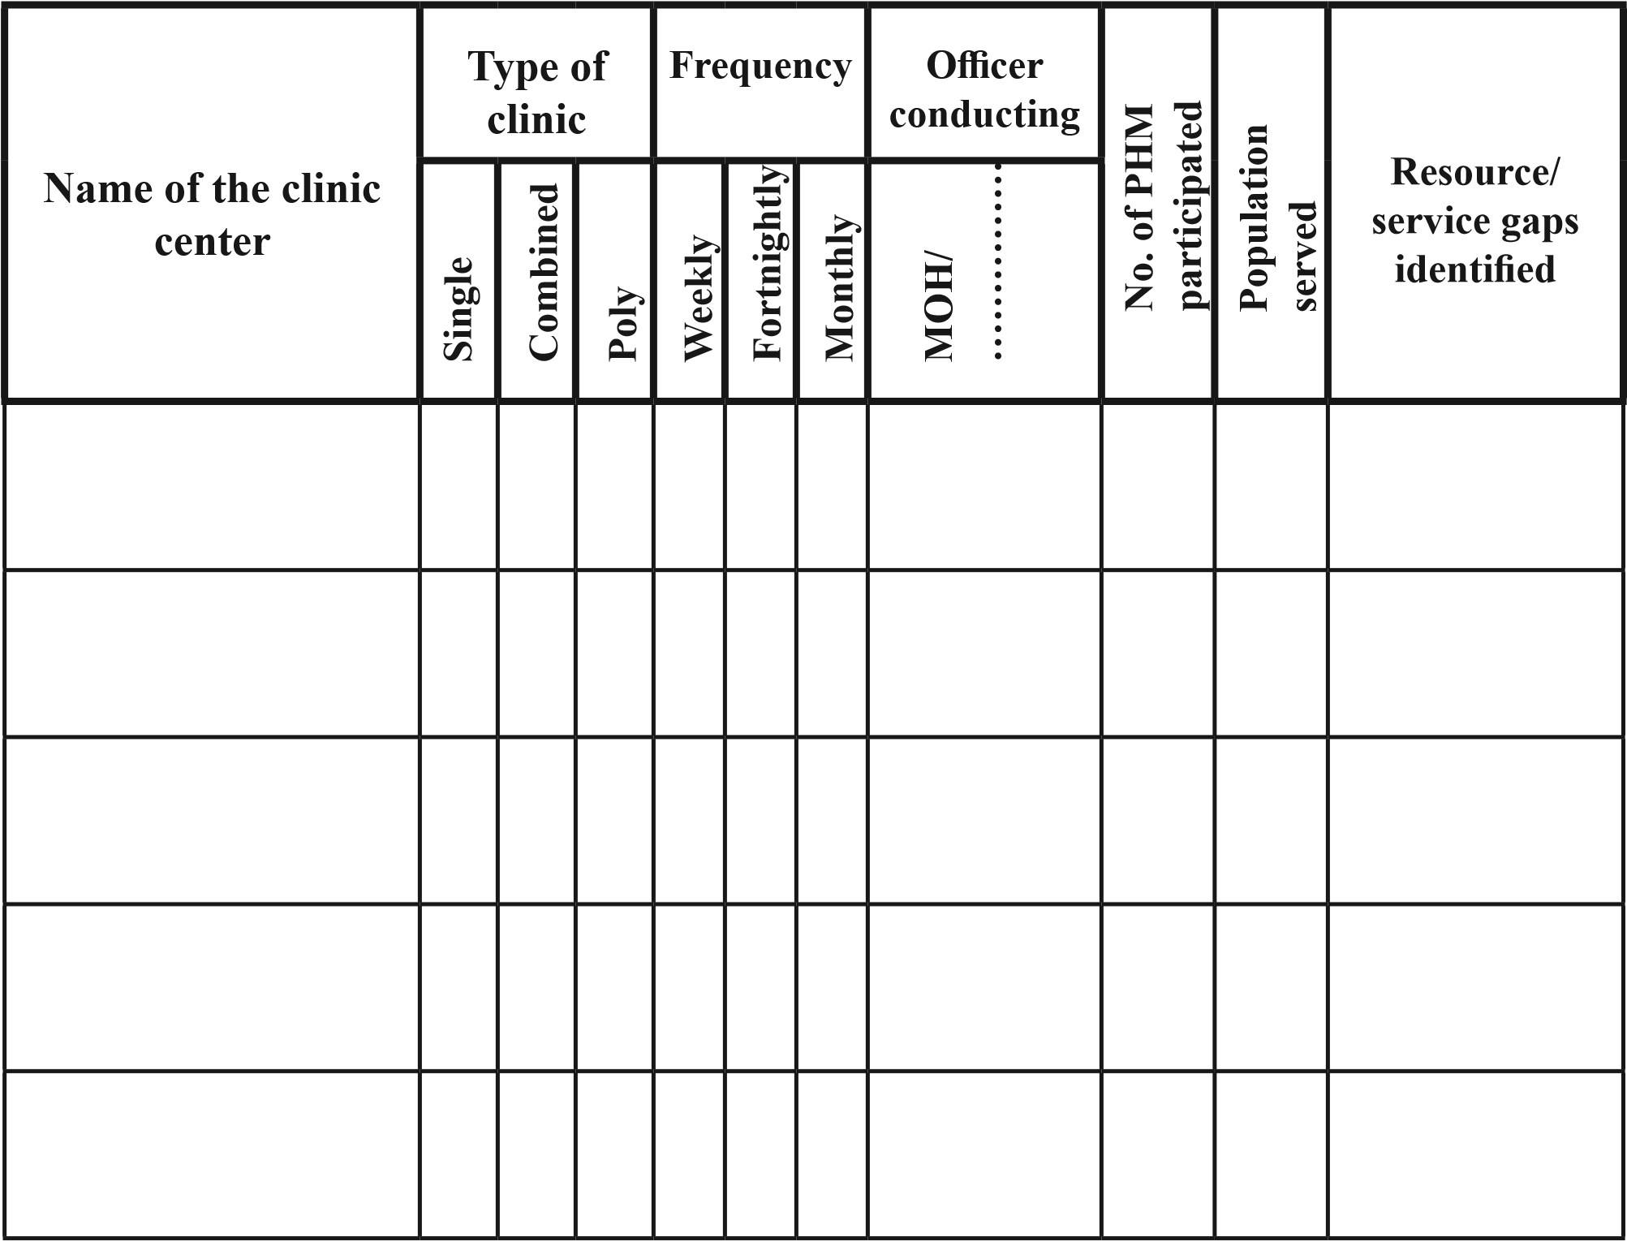
2. Human resource availability
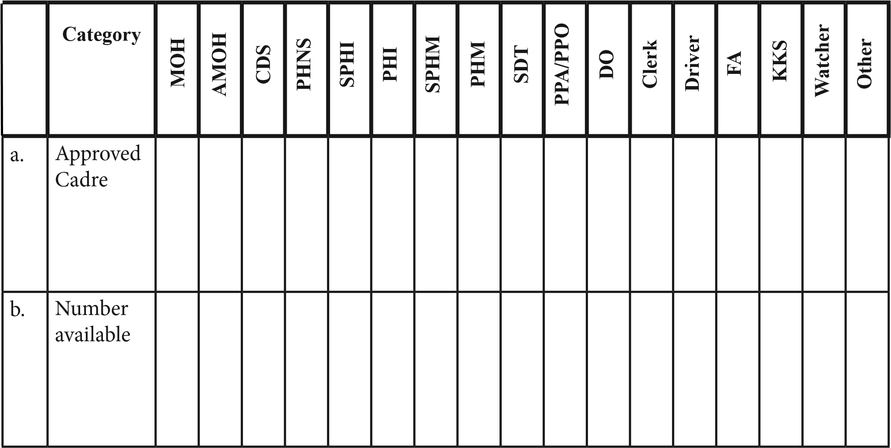

3. Clinic information
Comment on the clinic arrangement (number of clinic centres, type, schedule and population served) based on the information gathered according to the table below.

 |  | No. of centers | Clinic -  Population ratio |  | Comments
Availability of clinics | MCH Clinic
Availability of clinics | FP Clinic
Availability of clinics | WWC
Availability of clinics | Dental Clinic
 |  |  | Yes | No
Displayed in tables | Conducted every Saturday
Displayed in tables | Conducted regularly for last year
Adolescent health clinic | At least, one adolescent and youth-friendly health clinic conducted once or twice a month on a fixed day (e.g. fourth Saturday morning) at MOH office or in a field clinic.
Adolescent health clinic | Conducted regularly for last year
Adolescent health clinic | At least one nutrition clinic conducted once or twice a month on a fixed day
Adolescent health clinic | Conducted regularly for last year
Adolescent health clinic | Nutrition clinic register maintained regularly
Pre-conceptional sessions | Conduct at least 1 per month
Pre-conceptional sessions | Conducted regularly for last year
Well Woman Clinic Referrals | Well Woman Clinic –  Positive Client’s follow-up  Register maintained properly
Referral | Dates for different referral clinics are available

4. Planning
A. Annual plans |  | Yes | No
Availability | Available for the current year
Process in place | Situational analysis
 | Identification and prioritization of problems
Components of the plan mentioned (Goals, Objectives,
Activities)
Activity plan | Identification of activities, responsible person, time frame,  resources, and Indicators to monitor
Implementation | Evidence for implementation - plan, review done
Disaster Management Plan | Availability
Annual Advance  Programmes – available/  filled | Health Education - Covers important topics
Annual Advance  Programmes – available/  filled | SMI
Annual Advance  Programmes – available/  filled | All field officers (approved for current month and previous 6 months)
B. Conferences
Monthly Conferences | Conducted every month for the last year
Monthly Conferences | Reports available for all conferences
Monthly Conferences | Dates scheduled for this year

Local Conferences | Conducted every month for the last year for each PHI area
Local Conferences | Reports available for all
Local Conferences | Dates scheduled for this year
Local Conferences | Participation of all categories observed
Conduct regular reviews | Monthly / Quarterly / Annually
Implementation | Evidence for implementation - plan, review done
C. Surveys
Self-initiated survey/s  organized for the  MOH area | Conducted at least two for the last year
Self-initiated survey/s  organized for the  MOH area | Report available/pending
Self-initiated survey/s  organized for the  MOH area | Evidence for utilization of findings
Customer satisfaction surveys | Conducted for last year
Customer satisfaction surveys | Report available/pending
Customer satisfaction surveys | Evidence for utilization of findings

5. Immunization |  | Yes | No | Comments
Refrigerator | Ice-lined refrigerator available
Refrigerator | Condition of the ice-liner satisfactory
Refrigerator | Cool packs are adequate
Vaccine Movement Register | Available
Vaccine Movement Register | Updated
Vaccine Movement Register | Responsibility assigned for maintenance
Vaccine Movement Register | Vaccine carriers are available
Cold Chain Monitoring | VVM/Log tag / Freeze tag indicator (reading done daily)
Cold Chain Monitoring | Standard temperature monitoring chart available
Cold Chain Monitoring | Temperature monitoring chart updated
Cold Chain Monitoring | Log tag temperature chart printout is taken two weekly
Cold Chain Monitoring | Responsibility assigned for maintenance
Cold Chain Monitoring | Power backup available for power failures
Vaccine storage | Stored according to guidelines
Vaccine storage | Vaccines arranged on first come – first out basis
Vaccine storage | Vaccines arranged according to expiry dates
Autoclaves | Availability of sterilization chart

6. Office and stores management
A. Annual estimations |  | Yes | No | Comments
Micronutrients | Annual estimations carried out for the current year
Micronutrients | Documents available
Micronutrients | Accurate
Printed formats | Annual estimations carried out for the current year
Printed formats | Documents available
Printed formats | Accurate (Maximum, minimum &  buffer stock levels indicated)
Vaccines/AD Syringes | Annual estimations carried out for the current year
Vaccines/AD Syringes | accurate
FP commodities | Annual estimations carried out for the current year
FP commodities | accurate
B. Storage
 | All the items kept on shelves
 | Properly labeled
 | Stored in a logical manner
 | Shelf grids are marked with reference numbers
 | Stock levels marked (Max-green, Re-load-orange, Min – red) and accurate
 | Free of unnecessary items

C. Stock balance |  | Yes | No | Comments
Micronutrients | Stock balance documented and updated accurately
 | To check accuracy - usage from H1158, buffer stock etc. should be taken into consideration
Printed formats | Stock balance documented and updated accurately
FP commodities | Stock balance documented and updated accurately (stock level within maximum & buffer stock levels)
H-1158 | Maintained by PHMs and sent to MOH Office on time
H-1158 | Maintained at MOH Office and sent to RDHS Office on time
H-1158 | Accurate
D. Vehicle and equipment maintenance
(Files /Maintenance records/manuals)
Equipment | Available and updated
Vehicles | Available and updated
E. Files, folders,  cupboards | Arranged to facilitate identification
F. Inventory | Available for all staff members

7. Monitoring and evaluation
A. Staff Performances |  | Yes | No | Comments
Performance appraisal of staff based on objective methodology (based on  indicators) | PHM
 | PHI
 | Others
Performance appraisal | Available quarterly/annually
Performance appraisal | A rewarding mechanism in place
Performance appraisal | Accurate (Maximum, minimum &  buffer stock levels indicated)
B. Timeliness
Timeliness records | Maintain timeliness for all records received and send
Timeliness records | Displayed (PHM,PHI)

C. Death investigation |  |  |  |  |  | Yes | No | Comments
Maternal Deaths | Number of maternal deaths reported during last year
Maternal Deaths | How the informa-  tion is  obtained | PHM | Hospital | Media | Other (specify)
Maternal Deaths | Notification done within 24 hours |  |  |  |  |  |  | Date/s:
Maternal Deaths | Field maternal death investigations done within 14 days
Maternal Deaths | Report sent in time with relevant documents
Maternal Deaths | Supervision conducted on the relevant area PHM
Maternal Deaths | PHM supervision report available
Maternal Deaths | Lessons learnt from maternal death discussed at Monthly Conference
Infant Deaths | Number of infant deaths reported during last year
Infant Deaths | How the informa-  tion is  obtained | PHM | Hospital | Media | Other (specify)
Infant Deaths | Notification done within 24 hours |  |  |  |  |  |  | Date/s:
Infant Deaths | Field infant death investigations done within 14 days
Infant Deaths | Report sent in time with relevant documents
Infant Deaths | Lessons learnt from infant death discussed at Monthly Conference

D. Family planning
1. Failures of family planning methods:
Family Planning method | No. of failures  reported by PHMM | No. notified* | No. investigated*
*Please include only the ones where the relevant format has been sent.
2. Complications due to family planning methods:
Complication | Method | No. of complications  reported by  PHMM | No. notified* | No. investigated*
*Please include only the ones where the relevant format has been sent.

E. Maintenance of data / information |  |  | Yes |  |  | No |  | Comments
Record storing |  | Availability of a record room/space
 |  | Organized by the return type and the year
Data Management |  | Computer-based data management system available (Other than  eRHMIS)
 |  | Database for a minimum of 2 years
 | F. Review of MOH performances quarterly |  |  | Yes | No |  | Comments
 | Analysis of the problems done
 | Presented to the staff
 | Discussed for action

8. Supervision
 |  | Yes | No | Comments
Roster | Common Supervision Roster available
Roster | Timely updated
% of Supervisions done by the supervising officers
Total no. of supervisions done by
(
supervising officers in last year _{Total no. of supervisions due} ) x 100
by supervising officers in last year
Availability of supervision reports
Total no. of supervision reports available
(
for supervising officers in last year to the monthly statement
Total no. of supervisions according ) ^{x 100}
Quality of supervision reports (Select supervision reports randomly, one from each category available) | Objective mentioned
 | Supervision tally with the objectives
 | Recommendations done
 | Action plan to overcome weak points included
 | Positive findings identified
 | To be improved areas identified
 | Follow up process suggested
Separate files are maintained for the respective supervisee

9. Human resource development (last year)
 |  |  | Yes | No |  | Comments
In-service training schedule available
In-service training conducted
Training needs identified for all categories according to an objective method
Reports of the training available
 | Trainings received by officers | Number trained |  |  | Category
1 | Family Planning
2 | eRHMIS Training
3 | IUD insertion
4 | Life skill
5 | Adolescent health
6 | IYCF counseling
7 | GMP
8 | MOH Training
9 | Preconception care
10 | ECCD

10. Collective performances of moh staff in different service areas last year (can be taken from eRHMIS)
 |  | % | Comments
Antenatal | % of Eligible families registered
Antenatal | % of early registration (before 8 weeks)
Antenatal | % of pregnant mothers protected for  Rubella
Antenatal | Average number of Antenatal home visits
Antenatal | VDRL coverage
Intranatal | % of delivery reporting
Postnatal | % of postpartum mothers having  visited at least once during 1st 10 days
Postnatal | % of postpartum visits around 42 days
Postnatal | % of mothers reported with antenatal morbidities
Postnatal | % of mothers reported with postnatal morbidities
Infant and Child | % of infant registration
Infant and Child | Weighing coverage in infants
Infant and Child | % of infants underweight

 | Weighing coverage in 1-2 years
 | % of 1-2 years underweight
 | Weighing coverage in 2-5 years
 | % of 2-5 years underweight
 | % of infant deaths reported
School Health | SMI coverage
School Health | SMI coverage within Q1 + Q2
School Health | aTd coverage
School Health | % of School Sanitary Surveys conducted within Q1
Well Woman | Coverage of 35 year cohort in WWC clients
Well Woman | Coverage of 45 year cohort in WWC clients
Family Planning | Contraceptive Prevalence
Family Planning | Modern Method Prevalence
Family Planning | % of UMN in FP
Family Planning | % of IUD users
Family Planning | % of Teenage Pregnancies

11. Responsiveness
 |  | Yes | No | Comments
Clients | Information desk for outsiders available
Clients | Display of service availability
Clients | Complaint box available
Clients | Maintenance of a Complaint book
Clients | Evidence for attending complaints
Staff | Staff motivation survey/s done

12. Special activities done
At least 1 activity done for each/ per year - ( Except to routine activities)
 | Yes | No | Comments
Adolescent Health (for out of school attendees)
NCD prevention
Counselling services
Volunteers
Community mobilization
Advocacy

13. Observations
 | Strong points | Points to be strengthened
1.
2.
3.
4.
5.
Supervision Outcome Report

1. Components covered in the supervision
- ………………………………………………………………………………………………………
- ………………………………………………………………………………………………………
- ………………………………………………………………………………………………………IV. ………………………………………………………………………………………………………
V. ………………………………………………………………………………………………………

2. Overall comments
…………………………………………………………………………………………………………
…………………………………………………………………………………………………………
…………………………………………………………………………………………………………

3. Strong points/ areas identified during supervision
1……………………………………………. ……………………………………………. 2……………………………………………. .……………………………………………
3……………………………………………. .…………………………………………… 4……………………………………………. …………………………………………….
5…………………………………………….…………………………………………….

4. Action plan for areas/ points to be strengthened
 | Points to be strengthened | Proposed activity | Time frame
1
2
3
4
5
**Please limit the action plan only to 5 activities per supervision.

……………………………………………………………………………………………………
……………………………………………………………………………………………………
……………………………………………………………………………………………………
Name of supervising officer : …………………………..… Designation : ………………… Signature of supervising officer : ………………………… Date : ………………..………… Date for next supervision: ………………………………...

6. Recommendations of senior supervising officer
- ……………………………………………………………………………………………………
……………………………………………………………………………………………………
……………………………………………………………………………………………………
5. Suggestions of the supervisee to improve service provision
……………………………………………………………………………………………………
……………………………………………………………………………………………………
……………………………………………………………………………………………………
Date : ……………………………….. Signature : ………………………............ Designation : ………………………………
- ………………………………………………………………………………………………………………………………………………………………………………………………………...
…………………………………………………………………………………………………...
……………………………………………………………………………………………………
……………………………………………………………………………………………………
Date : ……………………………….. Signature : ………………………............
Designation : ………………………………

