Section 2
Public Health Nursing Sister - Office Supervision
- Name of supervising officer : ………………………………………………………………………………
- Designation of the supervising officer: -…………………………………………………...………………
- Date of supervision: -………………………………………………………………………..………………
- MOH area: -………………………………………………………………………………..………………
- Name of the PHNS:- ………………………………………………………………………..………………
- Objective of the supervision: -……………………………………………………………………………
- Was the PHNS informed regarding the supervision: Yes / No
- Basic information
Size of the area | :………………………………………….sq km
Population | :………………………………………………………
Date of first appointment | :………………………………………………………
Date of appointment to this area :……………………………………………………… Duration of service as a PHNS :……………………………………………………....
Transport facilities : Provided / Not provided
Is the PHNS in complete uniform? : Yes / No
Number of PHMs to be supervised :………………………………………………………
Number of SPHMs to be supervised :………………………………………………………
Approved cadre of PHNS for the MOH area :……………………………………………
Available no. of PHNSs for the MOH area :……………………………………………
- General condition of the office
No. |  | Yes | No | Remarks
i | Maintained in a place approved by the MOH
ii | Situated in a suitable area
iii | Official name board is displayed
iv | Cleanliness of the office is satisfactory
v | Office is well organized
vi | During duty hours. Office is accessible for supervision
- Office arrangements
 | Details to be displayed in the wall | Yes | No | Remarks
a | Area Map  i. Maintains according to department guidelines
a | ii. Following things are marked in the map PHM areas
a | Clinic centers
a | Weighing posts
a | Health institutions
a | Schools are marked
b | Vital Statistics and important indicators  Followings are displayed according to national,  Provincial, District and MOH levels
 | Birth rate
 | Infant mortality rate
 | Child mortality rate ( Children less than 5 years)
 | Maternal mortality rate
 | Low birth weight rate
 | Contraceptive prevalence
c | Approved advanced program for the month is displayed
d | Annual clinic plan
 | Annual plan with dates of clinic sessions available
 | Schedule for clinic participation pf PHMs is displayed
e | Names of PHMs under her supervision, population, number of houses, and eligible couples are displayed
f | Annual supervision roster is displayed
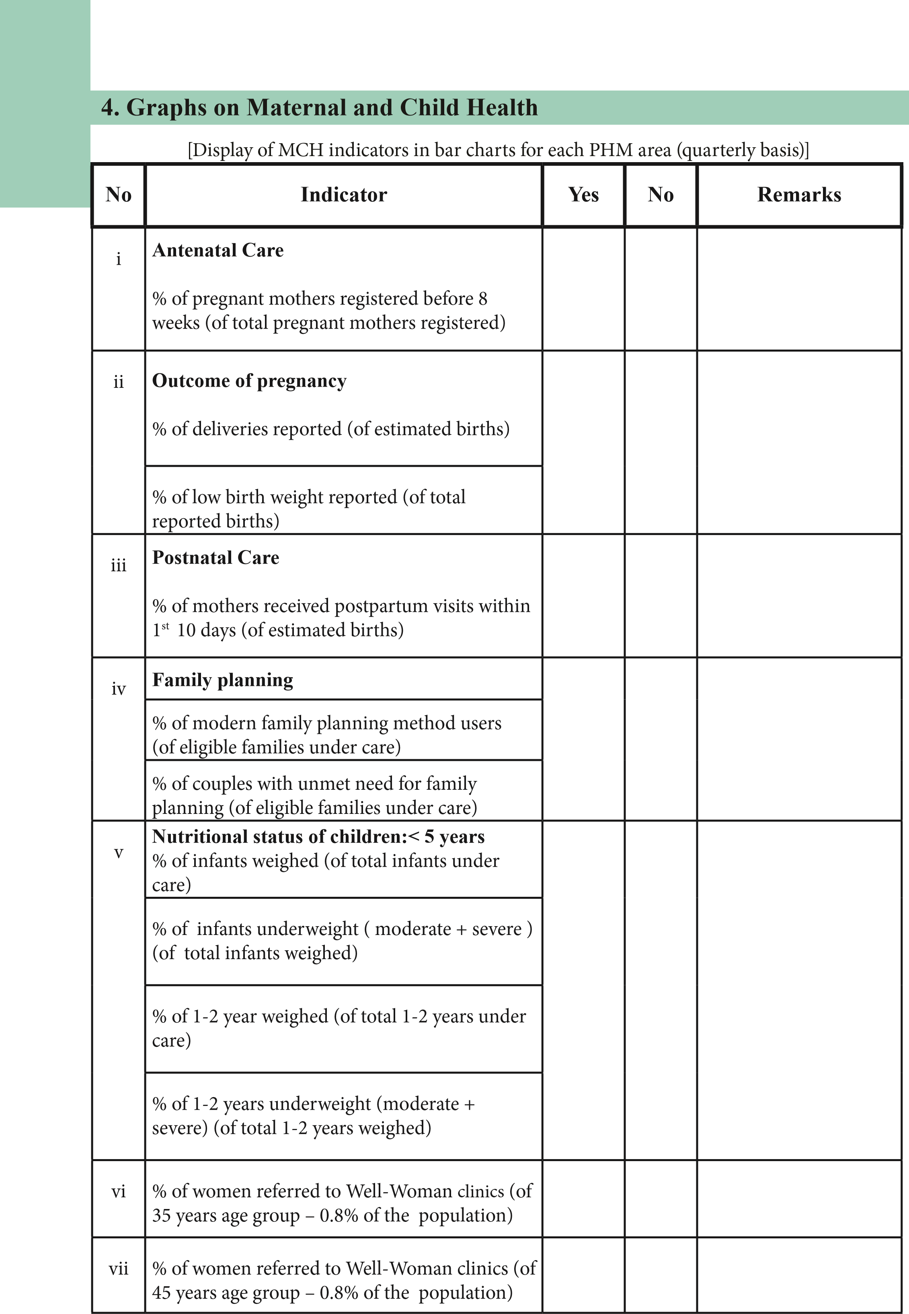
5. Maintenance of registers, records and returns at PHNS’s office
No. |  |  | Yes | No | Remarks
i | Duty List | Duty list of following officers are available PHNS
i | Duty List | SPHM
i | Duty List | PHM
ii | Diary | Duly completed
ii | Diary | Tallies with the advanced program and deviation book
iii | Registers | Register for Departmental circulars
iii | Registers | Inventory Register
iii | Registers | Register on issues of printed forms,  Drugs, stationery and equipment for  PHMM
iv | Files | Separare files for each PHM and  SPHM  ( may be used commonly by both  PHNS & SPHM )
iv | Files | Supervision reports file
iv | Files | Diary of PHNS
iv | Files | Monthly statement of PHNS form A
iv | Files | Files for MCH/FP returns ( eg : H 524 ,H 527 )
iv | Files | File for quarterly evaluation reports
iv | Files | File on special activities
iv | Files | Reports of infant death investigations
 | 6. MCH services - planning, implementation and monitoring
 | No | Main problems identified by the PHNS | Action  Plan is  Available/  Not available | Obtained  The  MOHs’  Approval  Yes/No | Progress
 | 1
 | 2
 | 3
 | 4
 | 5
- Contribution for the Management of Information System (MIS)
No |  | Yes | No | Remarks
i | A process in place to get monthly returns from PHMs’ on time
Ii | Analyses monthly and quarterly data sets in eRHMIS and identify quality gaps
iii | Identified problems are discussed at the monthly and local conferences and interventions are made
iv | Infant deaths are investigated timely and reports are submitted
v | At the end of each quarter, quarterly evaluation reports are submitted to the MOH
vi | A mechanism is in place to evaluate the service delivery of PHM on a regular basis
- Capacity building of health staff
Training needs of PHMs identified | Training programs planned  Yes/No | Training programs conduced  Yes/No
- In- service training received by the PHNS
Training | Yes/No | If received. The date of training
Training on Management Information System
GBV (3 DAYS)
Training on WWC program
IYCF Counselling
Family planning
GMP
ASRH
ECCD
Preconception care
Life skills (3 days)
EPI Middle-Level Managers
eRHMIS
 | 10. Service provision according to service needs
 | No. |  | Yes | No | Remarks
 | i | A model clinic has been organized in the MOH area
 | ii | Clinics are conducted in the absence of MOH
 | iii | PAP smears are taken under the supervision of the  MOH
 | iv | Draws blood for VDRL / Grouping & Rh
 | v | Participates in school health activities
 | vi | Supports MOH in maternal death investigations
 | vii | Conduct training programs for volunteers
 | viii | Identifies children with special needs in the area and pays special attention to them
 | ix | Supporting health-promoting sessions
- Number of supervisions – (done in the last quarter):
No. |  | Yes | No | Remarks
i | Number of supervisions planned
ii | Number of supervisions done according to the diary
iii | Number of supervisions done according to Monthly statement
iv | Number of supervisions done as follow-up supervisions
- Types of supervisions conducted
Total number of supervisions done during the previous quarter: …………………..
No. |  | No. | Remarks
i | PHM office – General supervision
ii | PHM Service component – Office supervision
iii | PHM Service component – Field supervision
iv | Clinics
v | Weighing posts
vi | SPHM office
vii | Planned supervision conducted for PHMs based on identified problems
viii | Identifies children with special needs in the area and pays special attention to them
- Supervision reports of PHM / SPHM : (supervisions done during the previous quarter)
No. |  | No. | % | Remarks
i | Number of supervision reports completed
ii | Number of reports submitted to the MOH for approval
iii | Number of supervision reports given to PHM / SPHM within a week

- Quality of supervisions: ( please analyze 3 supervision reports done recently)
No. |  | Report 1  Yes / No | Report 2  Yes / No | Report 3  Yes / No | Comments
i | There is an objective for the supervision
ii | Supervision has been done according to the objectives
iii | Relevant registers have been analyzed in depth
iv | Field visits have been done as part of the supervision
v | Recommendations have been made according to the observations
vi | Follow-ups are planned
vii | An action plan has been made for the problems identified
- Supervision of supervising public health midwife (SPHM ):
Supervisions conducted and submission of reports: ………………………………
(Number of supervisions done in the last 2 quarters )
No. |  | No. | Remarks
i | Number of supervisions planned for SPHM
ii | Number of supervisions done according to the diary
iii | Number of supervisions done according to Format A
iv | Number of reports handed over to the SPHM
v | Number of reports submitted according to Format A
16. Infant death investigations : (in the previous year)
Reported number of infant deaths :- ………………………………………………
Number of infant deaths investigated :- ……………………………………………….
- Role of PHNS in implementation and evaluation of the MCH Programme:
No. |  | Yes | No | Remarks
i | Has she guided PHMs on preparation of advance programmes to provide a quality service?
ii | Has she checked whether PHMs maintain their offices according to department guidelines?
iii | Has she evaluated MCH and family planning services quarterly?
iv | Has she given correct guidance to praise the strong points and strengthen the weak points of PHMs
v | Has she prepared evaluation reports of PHMs and shown them to the MOH to get his recommendations to improve their services?
- Distribution of printed forms, family planning commodities and micronutrients:
No. |  | Printed forms |  | FP commodities |  | Books and leaflets |  | Micronutrients
 |  | Yes | No | Yes | No | Yes | No | Yes | No
i | Annual estimates are prepared
ii | Estimates are made individually for each PHM
iii | Correct distribution is done through a register
iv | Logistics flow from PHM is monitored through H1158
v | H 1158 is prepared monthly at MOH and forwarded as required
vi | H 1158 information is taken into consideration when preparing annual estimates
- Special activities
No | Program / Activity | Reasons for the activity | Team participated | Date
i
ii
iii
iv
v
- Has she done a self–evaluation to maintain her duties in an optimum capacity:
No |  | Yes | No | Remarks
i | At the end of every day, she evaluates whether activities were done according to the advanced program
ii | She is keen on using the diary, advanced program, supervision roster, and action plans for this purpose
iii | Has she used a checklist to do all these?
iv | She has taken steps to rectify the problems
- List the problems identified by PHNS during self-evaluation:
………………………………………………………………………………………………………
………………………………………………………………………………………………………
………………………………………………………………………………………………………
………………………………………………………………………………………………………
- ………………………………………………………………………………………………………
- ………………………………………………………………………………………………………
- ………………………………………………………………………………………………………IV. ………………………………………………………………………………………………………
V. ………………………………………………………………………………………………………
2. Overall comments
…………………………………………………………………………………………………………
…………………………………………………………………………………………………………
…………………………………………………………………………………………………………

3. Strong points/ areas identified during supervision
Supervision Outcome Report
1. Components covered in the supervision
1……………………………………………. ……………………………………………. 2……………………………………………. .……………………………………………
3……………………………………………. .…………………………………………… 4……………………………………………. …………………………………………….
5…………………………………………….…………………………………………….
- Action plan for areas/ points to be strengthened
 | Points to be strengthened | Proposed activity | Time frame
1
2
3
4
5
**Please limit the action plan only to 5 activities per supervision.

- Suggestions of the supervisee to improve service provision
……………………………………………………………………………………………………
……………………………………………………………………………………………………
……………………………………………………………………………………………………
……………………………………………………………………………………………………
Name of supervising officer : …………………………..… Designation : ………………… Signature of supervising officer : ………………………… Date : ………………..………… Date for next supervision: ………………………………...

6. Recommendations of senior supervising officer
- …………………………………………………………………………………………………… ……………………………………………………………………………………………………
……………………………………………………………………………………………………
……………………………………………………………………………………………………
……………………………………………………………………………………………………
Date : ……………………………….. Signature : ………………………............ Designation : ………………………………
- ………………………………………………………………………………………………………………………………………………………………………………………………………...
…………………………………………………………………………………………………...
……………………………………………………………………………………………………
……………………………………………………………………………………………………
Date : ……………………………….. Signature : ………………………............
Designation : ………………………………

