**Section 2**

**Public Health Nursing Sister - Office Supervision**

1. Name of supervising officer : ………………………………………………………………………………
2. Designation of the supervising officer: -…………………………………………………...………………
3. Date of supervision: -………………………………………………………………………..………………
4. MOH area: -………………………………………………………………………………..………………
5. Name of the PHNS:- ………………………………………………………………………..………………
6. Objective of the supervision: -……………………………………………………………………………
7. Was the PHNS informed regarding the supervision: Yes / No
8. **Basic information**

|  |  |
| --- | --- |
| Size of the area | :………………………………………….sq km |
| Population | :……………………………………………………… |
| Date of first appointment | :……………………………………………………… |

Date of appointment to this area :……………………………………………………… Duration of service as a PHNS :……………………………………………………....

Transport facilities : Provided / Not provided

Is the PHNS in complete uniform? : Yes / No

Number of PHMs to be supervised :………………………………………………………

Number of SPHMs to be supervised :………………………………………………………

Approved cadre of PHNS for the MOH area :……………………………………………

Available no. of PHNSs for the MOH area :……………………………………………

1. **General condition of the office**

|  |  |  |  |  |
| --- | --- | --- | --- | --- |
| **No.** |  | **Yes** | **No** | **Remarks** |
| i | Maintained in a place approved by the MOH |  |  |  |
| ii | Situated in a suitable area |  |  |  |
| iii | Official name board is displayed |  |  |  |
| iv | Cleanliness of the office is satisfactory |  |  |  |
| v | Office is well organized |  |  |  |
| vi | During duty hours. Office is accessible for supervision |  |  |  |

1. **Office arrangements**

|  |  |  |  |  |
| --- | --- | --- | --- | --- |
|  | **Details to be displayed in the wall** | **Yes** | **No** | **Remarks** |
| a | Area Map  i. Maintains according to department guidelines |  |  |  |
| ii. Following things are marked in the map PHM areas |  |  |  |
| Clinic centers |  |  |  |
| Weighing posts |  |  |  |
| Health institutions |  |  |  |
| Schools are marked |  |  |  |
| b | Vital Statistics and important indicators  Followings are displayed according to national,  Provincial, District and MOH levels |  |  |  |
|  | Birth rate |  |  |  |
| Infant mortality rate |  |  |  |
| Child mortality rate ( Children less than 5 years) |  |  |  |
| Maternal mortality rate |  |  |  |
| Low birth weight rate |  |  |  |
| Contraceptive prevalence |  |  |  |
| c | Approved advanced program for the month is displayed |  |  |  |
| d | Annual clinic plan |  |  |  |
|  | Annual plan with dates of clinic sessions available |  |  |  |
|  | Schedule for clinic participation pf PHMs is displayed |  |  |  |
| e | Names of PHMs under her supervision, population, number of houses, and eligible couples are displayed |  |  |  |
| f | Annual supervision roster is displayed |  |  |  |

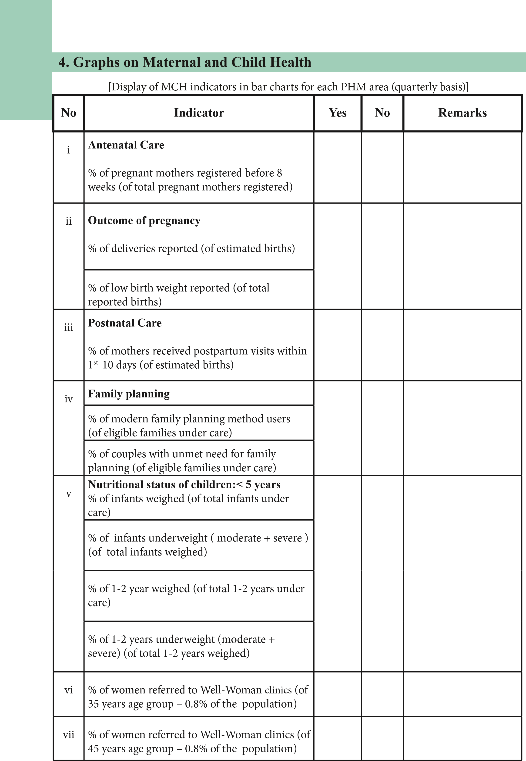

**5. Maintenance of registers, records and returns at PHNS’s office**

|  |  |  |  |  |  |
| --- | --- | --- | --- | --- | --- |
| **No.** |  |  | **Yes** | **No** | **Remarks** |
| i | Duty List | Duty list of following officers are available PHNS |  |  |  |
| SPHM |  |  |  |
| PHM |  |  |  |
| ii | Diary | Duly completed |  |  |  |
| Tallies with the advanced program and deviation book |  |  |  |
| iii | Registers | Register for Departmental circulars |  |  |  |
| Inventory Register |  |  |  |
| Register on issues of printed forms,  Drugs, stationery and equipment for  PHMM |  |  |  |
| iv | Files | Separare files for each PHM and  SPHM  ( may be used commonly by both  PHNS & SPHM ) |  |  |  |
| Supervision reports file |  |  |  |
| Diary of PHNS |  |  |  |
| Monthly statement of PHNS form A |  |  |  |
| Files for MCH/FP returns ( eg : H 524 ,H 527 ) |  |  |  |
| File for quarterly evaluation reports |  |  |  |
| File on special activities |  |  |  |
| Reports of infant death investigations |  |  |  |

|  |  |  |  |  |  |
| --- | --- | --- | --- | --- | --- |
|  |  | | | | |
| **6. MCH services - planning, implementation and monitoring** | | | | |
|  | | | | |
| **No** | **Main problems identified by the PHNS** | **Action**  **Plan is**  **Available/**  **Not available** | **Obtained**  **The**  **MOHs’**  **Approval**  **Yes/No** | **Progress** |
|  |
| 1 |  |  |  |  |
| 2 |  |  |  |  |
| 3 |  |  |  |  |
| 4 |  |  |  |  |
| 5 |  |  |  |  |

1. **Contribution for the Management of Information System (MIS)**

|  |  |  |  |  |
| --- | --- | --- | --- | --- |
| **No** |  | **Yes** | **No** | **Remarks** |
| i | A process in place to get monthly returns from PHMs’ on time |  |  |  |
| Ii | Analyses monthly and quarterly data sets in eRHMIS and identify quality gaps |  |  |  |
| iii | Identified problems are discussed at the monthly and local conferences and interventions are made |  |  |  |
| iv | Infant deaths are investigated timely and reports are submitted |  |  |  |
| v | At the end of each quarter, quarterly evaluation reports are submitted to the MOH |  |  |  |
| vi | A mechanism is in place to evaluate the service delivery of PHM on a regular basis |  |  |  |

1. **Capacity building of health staff**

|  |  |  |
| --- | --- | --- |
| **Training needs of PHMs identified** | **Training programs planned**  **Yes/No** | **Training programs conduced**  **Yes/No** |
|  |  |  |
|  |  |  |
|  |  |  |
|  |  |  |
|  |  |  |

1. **In- service training received by the PHNS**

|  |  |  |
| --- | --- | --- |
| **Training** | **Yes/No** | **If received. The date of training** |
| Training on Management Information System |  |  |
| GBV (3 DAYS) |  |  |
| Training on WWC program |  |  |
| IYCF Counselling |  |  |
| Family planning |  |  |
| GMP |  |  |
| ASRH |  |  |
| ECCD |  |  |
| Preconception care |  |  |
| Life skills (3 days) |  |  |
| EPI Middle-Level Managers |  |  |
| eRHMIS |  |  |

|  |  |  |  |  |  |
| --- | --- | --- | --- | --- | --- |
|  |  | | | | |
| **10. Service provision according to service needs** | | | |  |
|  | | | |  |
| **No.** |  | **Yes** | **No** | **Remarks** |
|  | i | A model clinic has been organized in the MOH area |  |  |  |
| ii | Clinics are conducted in the absence of MOH |  |  |  |
| iii | PAP smears are taken under the supervision of the  MOH |  |  |  |
| iv | Draws blood for VDRL / Grouping & Rh |  |  |  |
| v | Participates in school health activities |  |  |  |
| vi | Supports MOH in maternal death investigations |  |  |  |
| vii | Conduct training programs for volunteers |  |  |  |
| viii | Identifies children with special needs in the area and pays special attention to them |  |  |  |
| ix | Supporting health-promoting sessions |  |  |  |

1. **Number of supervisions – (done in the last quarter):**

|  |  |  |  |  |
| --- | --- | --- | --- | --- |
| **No.** |  | **Yes** | **No** | **Remarks** |
| i | Number of supervisions planned |  |  |  |
| ii | Number of supervisions done according to the diary |  |  |  |
| iii | Number of supervisions done according to Monthly statement |  |  |  |
| iv | Number of supervisions done as follow-up supervisions |  |  |  |

1. **Types of supervisions conducted**

Total number of supervisions done during the previous quarter: …………………..

|  |  |  |  |
| --- | --- | --- | --- |
| **No.** |  | **No.** | **Remarks** |
| i | PHM office – General supervision |  |  |
| ii | PHM Service component – Office supervision |  |  |
| iii | PHM Service component – Field supervision |  |  |
| iv | Clinics |  |  |
| v | Weighing posts |  |  |
| vi | SPHM office |  |  |
| vii | Planned supervision conducted for PHMs based on identified problems |  |  |
| viii | Identifies children with special needs in the area and pays special attention to them |  |  |

1. **Supervision reports of PHM / SPHM : (supervisions done during the previous quarter)**

|  |  |  |  |  |
| --- | --- | --- | --- | --- |
| **No.** |  | **No.** | **%** | **Remarks** |
| i | Number of supervision reports completed |  |  |  |
| ii | Number of reports submitted to the MOH for approval |  |  |  |
| iii | Number of supervision reports given to PHM / SPHM within a week |  |  |  |

1. **Quality of supervisions: ( please analyze 3 supervision reports done recently)**

|  |  |  |  |  |  |
| --- | --- | --- | --- | --- | --- |
| **No.** |  | **Report 1**  **Yes / No** | **Report 2**  **Yes / No** | **Report 3**  **Yes / No** | **Comments** |
| i | There is an objective for the supervision |  |  |  |  |
| ii | Supervision has been done according to the objectives |  |  |  |  |
| iii | Relevant registers have been analyzed in depth |  |  |  |  |
| iv | Field visits have been done as part of the supervision |  |  |  |  |
| v | Recommendations have been made according to the observations |  |  |  |  |
| vi | Follow-ups are planned |  |  |  |  |
| vii | An action plan has been made for the problems identified |  |  |  |  |

1. **Supervision of supervising public health midwife (SPHM ):**

Supervisions conducted and submission of reports: ………………………………

(Number of supervisions done in the last 2 quarters )

|  |  |  |  |
| --- | --- | --- | --- |
| **No.** |  | **No.** | **Remarks** |
| i | Number of supervisions planned for SPHM |  |  |
| ii | Number of supervisions done according to the diary |  |  |
| iii | Number of supervisions done according to Format A |  |  |
| iv | Number of reports handed over to the SPHM |  |  |
| v | Number of reports submitted according to Format A |  |  |

|  |  |
| --- | --- |
|  | |
| **16. Infant death investigations : (in the previous year)** |  |
| Reported number of infant deaths :- ………………………………………………  Number of infant deaths investigated :- ………………………………………………. |

1. **Role of PHNS in implementation and evaluation of the MCH Programme:**

|  |  |  |  |  |
| --- | --- | --- | --- | --- |
| **No.** |  | **Yes** | **No** | **Remarks** |
| i | Has she guided PHMs on preparation of advance programmes to provide a quality service? |  |  |  |
| ii | Has she checked whether PHMs maintain their offices according to department guidelines? |  |  |  |
| iii | Has she evaluated MCH and family planning services quarterly? |  |  |  |
| iv | Has she given correct guidance to praise the strong points and strengthen the weak points of PHMs |  |  |  |
| v | Has she prepared evaluation reports of PHMs and shown them to the MOH to get his recommendations to improve their services? |  |  |  |

1. **Distribution of printed forms, family planning commodities and micronutrients:**

|  |  |  |  |  |  |  |  |  |  |
| --- | --- | --- | --- | --- | --- | --- | --- | --- | --- |
| **No.** |  | **Printed forms** | | **FP commodities** | | **Books and leaflets** | | **Micronutrients** | |
|  |  | **Yes** | **No** | **Yes** | **No** | **Yes** | **No** | **Yes** | **No** |
| i | Annual estimates are prepared |  |  |  |  |  |  |  |  |
| ii | Estimates are made individually for each PHM |  |  |  |  |  |  |  |  |
| iii | Correct distribution is done through a register |  |  |  |  |  |  |  |  |
| iv | Logistics flow from PHM is monitored through H1158 |  |  |  |  |  |  |  |  |
| v | H 1158 is prepared monthly at MOH and forwarded as required |  |  |  |  |  |  |  |  |
| vi | H 1158 information is taken into consideration when preparing annual estimates |  |  |  |  |  |  |  |  |

1. **Special activities**

|  |  |  |  |  |
| --- | --- | --- | --- | --- |
| **No** | **Program / Activity** | **Reasons for the activity** | **Team participated** | **Date** |
| i |  |  |  |  |
| ii |  |  |  |  |
| iii |  |  |  |  |
| iv |  |  |  |  |
| v |  |  |  |  |

1. **Has she done a self–evaluation to maintain her duties in an optimum capacity:**

|  |  |  |  |  |
| --- | --- | --- | --- | --- |
| **No** |  | **Yes** | **No** | **Remarks** |
| i | At the end of every day, she evaluates whether activities were done according to the advanced program |  |  |  |
| ii | She is keen on using the diary, advanced program, supervision roster, and action plans for this purpose |  |  |  |
| iii | Has she used a checklist to do all these? |  |  |  |
| iv | She has taken steps to rectify the problems |  |  |  |

1. **List the problems identified by PHNS during self-evaluation:**

………………………………………………………………………………………………………

………………………………………………………………………………………………………

………………………………………………………………………………………………………

………………………………………………………………………………………………………

1. ………………………………………………………………………………………………………
2. ………………………………………………………………………………………………………
3. ………………………………………………………………………………………………………IV. ………………………………………………………………………………………………………

V. ………………………………………………………………………………………………………

**2. Overall comments**

…………………………………………………………………………………………………………

…………………………………………………………………………………………………………

…………………………………………………………………………………………………………

# 3. Strong points/ areas identified during supervision

|  |  |
| --- | --- |
| **Supervision Outcome Report** | |
| **1. Components covered in the supervision** |  |
|  |

1……………………………………………. ……………………………………………. 2……………………………………………. .……………………………………………

3……………………………………………. .…………………………………………… 4……………………………………………. …………………………………………….

5…………………………………………….…………………………………………….

1. **Action plan for areas/ points to be strengthened**

|  |  |  |  |
| --- | --- | --- | --- |
|  | **Points to be strengthened** | **Proposed activity** | **Time frame** |
| 1 |  |  |  |
| 2 |  |  |  |
| 3 |  |  |  |
| 4 |  |  |  |
| 5 |  |  |  |

**Please limit the action plan only to 5 activities per supervision.

1. **Suggestions of the supervisee to improve service provision**

……………………………………………………………………………………………………

……………………………………………………………………………………………………

……………………………………………………………………………………………………

……………………………………………………………………………………………………

Name of supervising officer : …………………………..… Designation : ………………… Signature of supervising officer : ………………………… Date : ………………..………… Date for next supervision: ………………………………...

# 6. Recommendations of senior supervising officer

1. …………………………………………………………………………………………………… ……………………………………………………………………………………………………

……………………………………………………………………………………………………

……………………………………………………………………………………………………

……………………………………………………………………………………………………

Date : ……………………………….. Signature : ………………………............ Designation : ………………………………

1. ………………………………………………………………………………………………………………………………………………………………………………………………………...

…………………………………………………………………………………………………...

……………………………………………………………………………………………………

……………………………………………………………………………………………………

Date : ……………………………….. Signature : ………………………............

Designation : ………………………………