**Section 6**

**Infant, Child and Adolescent Care – Office Supervision**

1. Name of the supervising officer: …………………………………………………………….. 2. Designation of the supervising officer: ……………………………………………………....

1. Date of supervision : …………………………………………………………………....…….
2. MOH area : …………………………………………………….............……………….
3. PHM area : ………....……………………………………………………………….… 6. Name of the PHM : ………………………………………………………………………….
4. Objective of the supervision: …………………………………………………………………
5. Was the PHM informed regarding the supervision Yes/No
6. Is the PHM in complete uniform? Yes/No
7. Issues identified in the eRHMIS data related to child and adolescent care –

……………………………………………………………………...……………………………

……………………………………………………………………………………....……………

………………………………………………………………………....…………………………

……………………………………………………………………………………....……………

……………………………………………………………………………………....……………

……………………………………………………………………………………....……………

PHM area statistics

i. District Birth Rate : ……………………………………. ii Estimated births for PHM area : …………………………………….

**Data on Previous supervision on Infant, Child and Adolescent Care :**

Date of supervision : …………………………………………………………

Designation of the supervising officer :…………………………………………………………

Recommendations are implemented : Yes/No Note on recommendations that were not implemented:

……………………………………………………………………………………………

……………………………………………………………………………………………

1. **Care for infants during last quarter**

Compare the consistency of data using different records in a selected quarter

Quarter : …………………………………….

**Part - 1**

**Infant and Child Care**

|  |  |  |  |  |  |  |  |
| --- | --- | --- | --- | --- | --- | --- | --- |
| **No** | **Activity** | **No. in**  **H 524** | **No. in**  **H 523** | **No. in**  **Diary** | **No. in**  **CHDR B portions** | **No. in**  **H512 B** | **According to BI register** |
| 1 | Birth reporting |  |  |  |  |  |  |
| 2 | No of infants under care |  |  |  |  |  |  |
| 3 | Post-partum first visits during 1st 10 days after delivery |  |  |  |  |  |  |
| 4 | Infants registered |  |  |  |  |  |  |
| 5 | Infants received home visit after 42 days |  |  |  |  |  |  |
| 6 | Low birth weight reported |  |  |  |  |  |  |

1. **Consistency of data on children under care**

|  |  |  |  |  |  |
| --- | --- | --- | --- | --- | --- |
| **Age group** | **Estimated** | **No. in H 524** | **No. of CHDR**  **B** | **No. in BI register** | **No. in growth monitoring register** |
| Infants |  |  |  |  |  |
| 1 – 2years |  |  |  |  |  |
| 2 – 5 years |  |  |  |  |  |
| Total |  |  |  |  |  |

1. **Consistency of data on child care: cross-check few entries in different records**

|  |  |  |  |  |
| --- | --- | --- | --- | --- |
| **No** |  | **Yes** | **No** | **Comments** |
| 1 | B portions are separated according to villages and year of birth (and easily traceable) |  |  |  |
| 2 | No. of children in 1 -2 and 2 – 5 age groups in the BI register tallies with the monthly report |  |  |  |
| 3 | No. of weighing in the B portion and GMP register and daily statement tally with each other? |  |  |  |
| 4 | No. of length/height measurements in the B portion and GMP register and daily statement tally with each other? |  |  |  |
| 5 | Home visits made for preschool children as written in the diary tallies with that in the daily statement. |  |  |  |
| 6 | Registration dates of the BI register, CHDR B portions and diary tallies with each other. |  |  |  |

1. **Immunization coverage**

|  |  |  |  |  |  |  |
| --- | --- | --- | --- | --- | --- | --- |
| **No** | **Vaccine** | **No. to be immunized**  **(for estimated births)** | **No.**  **Immunized**  **(B1 register)** | **%** | **% of ageappropriate**  **Immunization** | **Others** |
| 1 | BCG |  |  |  |  |  |
| 2 | PENTAVALENT 1 |  |  |  |  |  |
| 3 | JE |  |  |  |  |  |
| 4 | MMR 1st dose |  |  |  |  |  |
| 5 | MMR 2nd dose |  |  |  |  |  |
| 6 | DT & OPV (5th dose) |  |  |  |  |  |

For vaccines 1 to 4 the denominator should be No of children completed 1 year under care. For MMR II It should be the number of children completed 3 years and for DT children completed 5 years under care, respectively.

AEFI reporting during last quarter for number of total immunizations carried out during quarter.

No. …………………………… Percentage (%) ………………………

ii. No. of 1 – 2 years under care : …………………………………….. iii. No. of 2 - 5 years under care : …………………………………….. iv. No. of field weighing posts : ………………………………………..

|  |  |
| --- | --- |
|  | |
| **5. Adequacy of child weighing centers** |  |
| i. No. of infants under care : ………………………………………. |

v. No. of field weighing posts : Adequate / Not adequate/ More than required vi. Annual schedule for field weighing posts is available with dates : Yes / No iv. Spread of field weighing posts in the map and assess accessibility:

Satisfactory / Not satisfactory

**6. Nutritional status of under 5 years children**

1. **Take the information using growth monitoring register**

|  |  |  |  |  |  |  |  |  |
| --- | --- | --- | --- | --- | --- | --- | --- | --- |
|  | | | **Measuring weight** | | | |  | |
| **Infants (last month)** | | | **Children 1 -2 (last month)** | | | | **Children 2 – 5 yrs**  **(last quarter)** | |
| **No. to be measured** | **No.**  **measured** | | **No. to be measured** | **No. measured** | | | **No. to be measured** | **No. measured** |
|  |  | |  |  | | |  |  |
|  | | | **Measuring length** | | |  | | |
| **Infants (last month)** | | | **Children 1 -2 (last month)** | | | **Children 2 – 5 yrs**  **(last quarter)** | | |
| **No. to be measured** | | **No.**  **measured** | **No. to be measured** | | **No. measured** | **No. to be measured** | | **No. measured** |
|  | |  |  | |  |  | |  |

1. **status of weighing of < 5 year children**

(use a sample of 10 children from each category using growth monitoring register or CHDR B portions ):

|  |  |  |  |
| --- | --- | --- | --- |
|  |  | **No.** | **%** |
| Children completed one year | Weighed once a month regularly |  |  |
| Weighed at least 9 times |  |  |
| Children completed 2 years | Weight once a month regularly during age 1 – 2 yrs |  |  |
| Weighed at least 9 times during age 1 - 2 |  |  |
| Children completed 5 years | No. weighed once in three months regularly during age 2 – 5 yrs |  |  |
| No. weighed more frequently than once in 3 months during age 2 -5 yrs |  |  |

1. **Status of length/ height measuring of < 5 year children**

(use a sample of 10 children from each category using growth monitoring register or CHDR B portions ):

|  |  |  |  |
| --- | --- | --- | --- |
| **Age category** | **Norm** | **No.** | **%** |
| Children completed 2 years | Length measured at least 4 times (4, 9, 12 and 18 months) |  |  |
| Children completed 5 years | Height measured once in six months regularly during age 2 – 5 yrs |  |  |
| Height measured more frequently than once in 6 months during age 2 - 5 yrs |  |  |

1. **Nutritional status of < 5 year children during the last month according to H – 524**

|  |  |  |  |  |  |  |  |  |  |  |
| --- | --- | --- | --- | --- | --- | --- | --- | --- | --- | --- |
|  | **No under care** | **No.**  **Weighed** | **Moderate**  **Under weight**  **< - 2.SD to**  **-3 SD** | | **Severe underweight**  **< - 3 SD** | | **Normal weight +2SD to -2SD** | | **“Overweight”**  **>+2SD** | |
| **No.** | **%** | **No.** | **%** | **No.** | **%** | **No.** | **%** |
| Infants |  |  |  |  |  |  |  |  |  |  |
| Children 1 -2 years |  |  |  |  |  |  |  |  |  |  |
| Children 2 -5 years |  |  |  |  |  |  |  |  |  |  |
| **Total** |  |  |  |  |  |  |  |  |  |  |

Maintained according to instructions given :Yes / No

**Analysis of growth monitoring promotion register data**

GF by age category :Yes / No

Any growth problem by age category :Yes / No

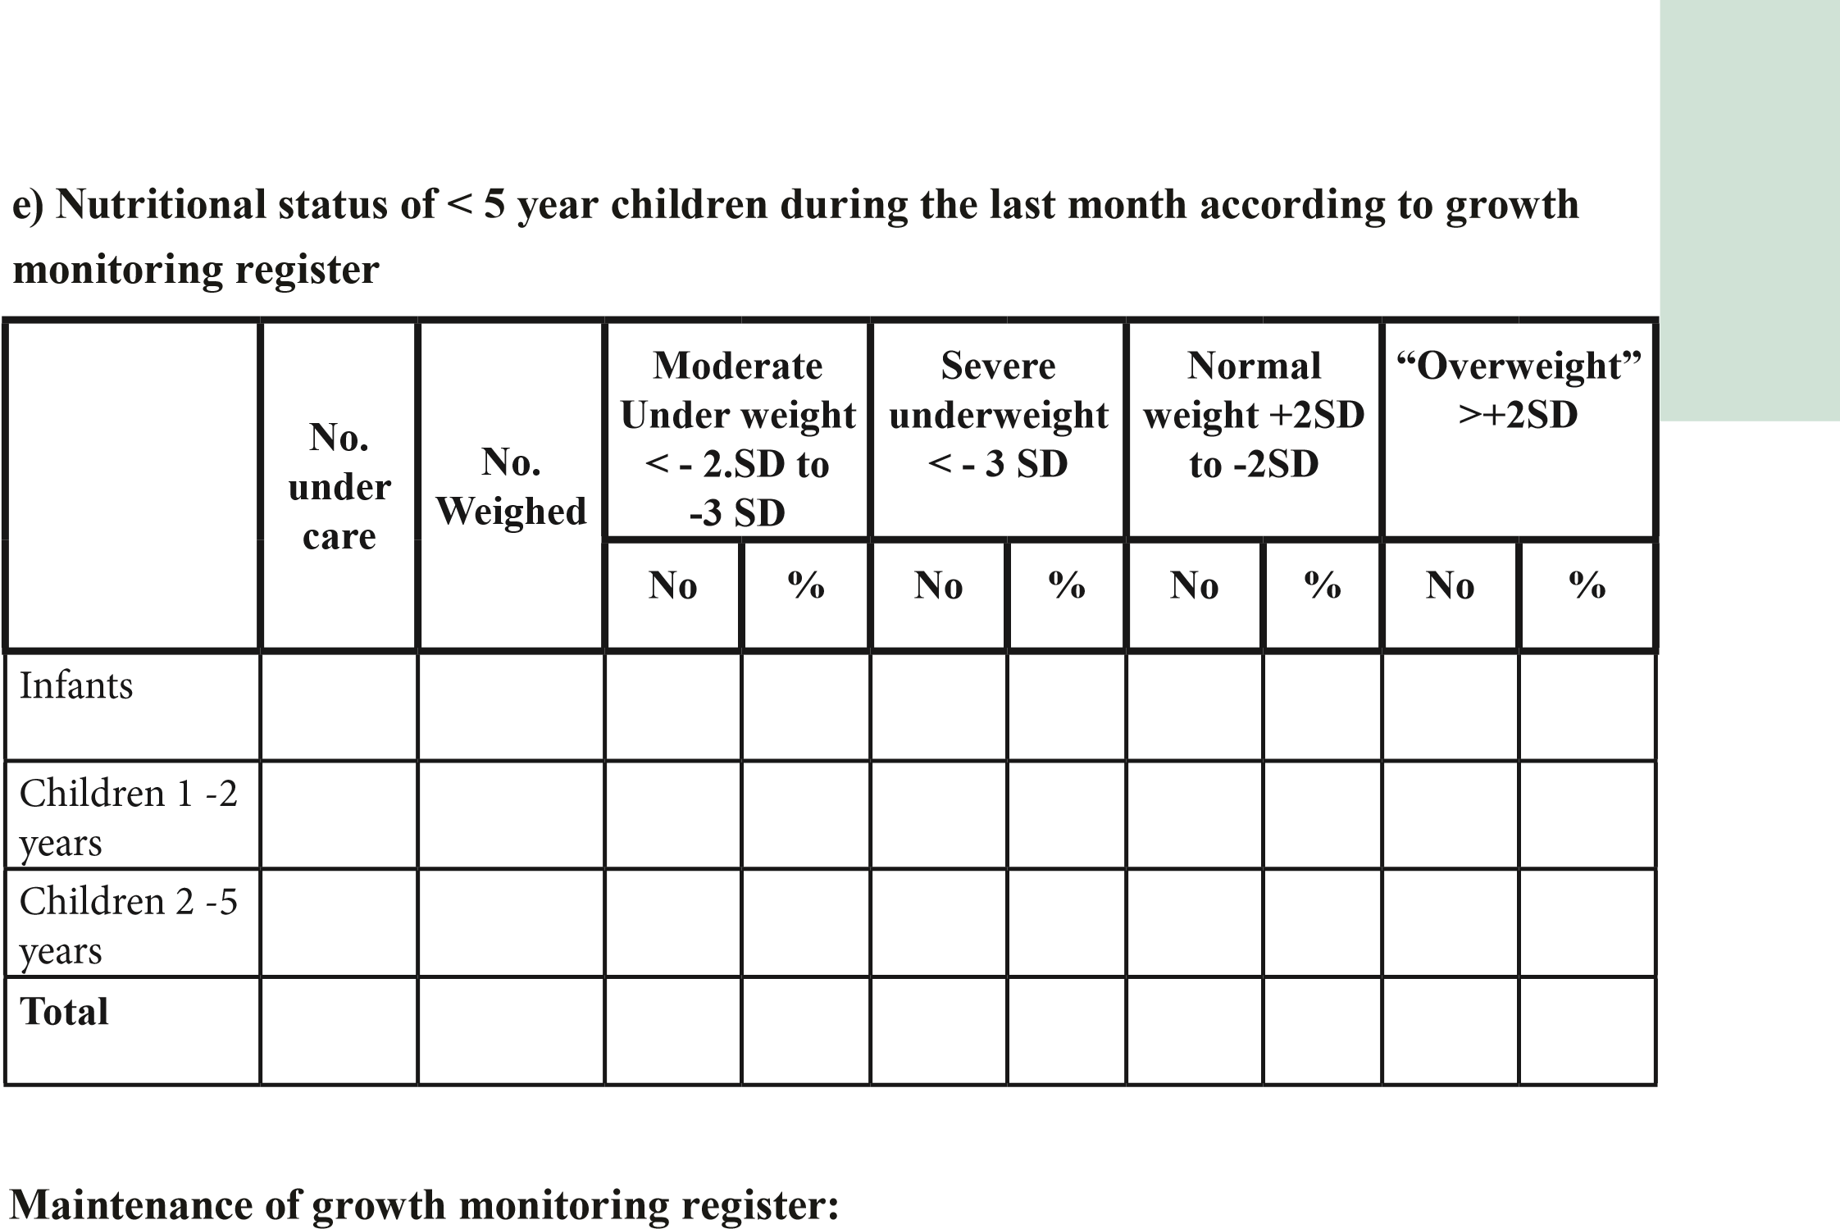 Trend of GF :Yes / No No. of SAM children :Yes / No

**Nutrition month data sheets –**

Data sheets and summary sheets maintained by year :Yes / No

1. **Breastfeeding and complementary feeding**

(Use randomly selected 10 – 20 CHDR B portions of infants completed 6 months)

|  |  |  |  |  |
| --- | --- | --- | --- | --- |
|  |  | **No.** | **%** | **Comments** |
| 1 | Infants who were initiated on breast feeding within 1 hour of birth |  |  |  |
| 2 | Infants who were exclusively breastfed for the first 6 months |  |  |  |
| 3 | Infants started on complementary feeding at the completion of 6 months |  |  |  |

1. **Assessment of psycho-social development**

(Check 20 CHDR B portions to cover all age groups – infants, 1 -2 years and 2 -5 years)

|  |  |  |  |  |
| --- | --- | --- | --- | --- |
|  |  | **No.** | **%** | **Comments** |
| 1 | Developmental stages are marked accordingly to the B Portion |  |  |  |
| 2 | Children prone to home accidents/ Risk factors are identified |  |  |  |
| 3 | Children wih special needs are identified |  |  |  |
| 4 | Extra home visits done for the Children who require special attention |  |  |  |

|  |  |  |  |
| --- | --- | --- | --- |
|  | **Yes** | **No.** | **Comments** |
| Percentage of adolescents under care (Out of estimate) (Registered in the eligible family register)* |  |  |  |
| Adolescents who are not in the eligible families are registered in the last pages in the eligible family register. |  |  |  |
| Follow up and monitor children till the age of 18 years by maintaining birth and immunization register |  |  |  |
| Maintain a separate register (Book) for adolescents care |  |  |  |

**2. Register on consistency of data on adolescents under care**

Compare the consistency of data using different records in a selected quarter

**Part - 2**

**Care for Adolescents**

**1**

**. Registration and followup**

Quarter : …………………………………….

|  |  |  |  |  |  |
| --- | --- | --- | --- | --- | --- |
| **No** | **Activity** | **No. in**  **H524** | **No. in**  **H523** | **No. in**  **Diary** | **According to eligible family**  **Register** |
| 1 | No. of adolescents under care |  |  |  |  |
| 2 | No. of adolescents registered |  |  |  |  |
| 3 | No. of home visits for adolescents |  |  |  |  |
| 4 | No. of problems identified (New) |  |  |  |  |
| 5 | No. intervene by PHM |  |  |  |  |
| 6 | No. refer to the MOH |  |  |  |  |