**Section 7**

**Family Planning Services – Office Supervision**

1. Name of the supervising officer: ……………………………...………………………………
2. Designation of the supervising officer: ………………………………………………………

3. Date of supervision: ……………………………………….…………………………………

1. MOH area : ……………………………………………..............………………………
2. PHM area : ………………………………….……………………………………….… 6. Name of the PHM : …………………………………..………………………………………
3. Objective of the supervision: ………………………………………………………………….
4. Was the PHM informed regarding the supervision Yes/No
5. Is the PHM in complete uniform? Yes/No
6. Issues identified in the eRHMIS data related to family planning services –

……………………………………………………………………………………………………

……………………………………………………………………………………………………

Page

42

……………………………………………………………………………………………………

……………………………………………………………………………………………………

……………………………………………………………………………………………………

Trained in family planning counselling - completed - :Yes/No

If yes, Date: ………………………………

**Data on previous supervision on family planing services:**

Date of supervision : …………………………………………………………

Designation of the supervising officer :…………………………………………………………

Recommendations are implemented : Yes/No Note on recommendations that were not implemented:

…………………………………………………………………………………………………

|  |  |
| --- | --- |
|  | |
| **1. information on family planning** |  |
| i. No. of eligible families under care : ………………………………………  ii. No. of FP current users : …………………………………..….. |

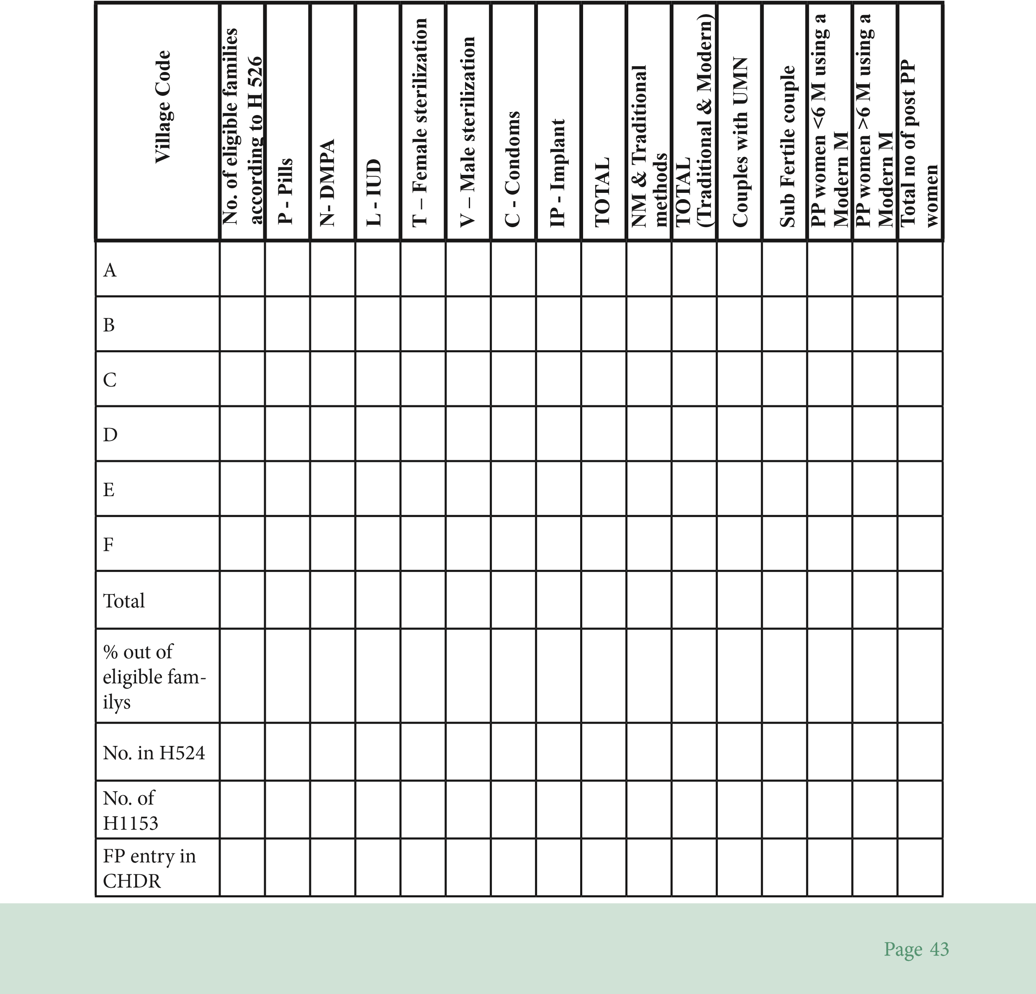………………………………………………………………………………………………… iii. No. of FP modern method users ………………………………………

iv. No. of natural/Traditional method users : ………………………………………

# 2. Consistency of data on family planning method used according to ef register (H 526), family planning record (H 1153), monthly report (H 524)

1. Action plan has been implemented successfully Yes/No
2. No. of UMN families changed to modern methods during the last quarter …………

# 4. Maintenance of family planning record (H 1153)

i. Kept according to villages Yes/No ii. Kept according to FP method Yes/No i. H 1153 tally with the eligible couples register Yes/No ii. H 1153 are duly completed Yes/No iii. Follow up done satisfactorily Yes/No iv. All women after the first pregnancy are issued a H1153 Yes/No

|  |  |  |
| --- | --- | --- |
|  | |  |
|  | **3. Actions taken to reduce the unmet need of family planning** |  |
| i. Has identified the unmet need (UMN) correctly accordingly to the definition | Yes/No |
| ii. Action plan has been prepared to reduce UMN of family planning | | Yes/No |

Check randomly selected 25 records of H 1153 to analyze the follow-up visits.

Page

44

|  |  |  |  |  |  |  |  |
| --- | --- | --- | --- | --- | --- | --- | --- |
|  | **Method** | **No. of cards selected** | **Recommended frequency of follow up visits** | **Had regular follow-up visits** | | **Had the last visit within last 6 months** | |
| **Yes** | **No** | **Yes** | **No** |
| a. | Pills |  | Monthly |  |  |  |  |
| b. | DMPA |  | For the first 3 months monthly, after that once in 3 months |  |  |  |  |
| c. | IUD |  | For the first 3 months monthly, thereafter once in 6 months |  |  |  |  |
| **d.** | Female  sterilization |  | Once a month for 3 months, after that every 6 months |  |  |  |  |
| **e.** | Implants |  | Once a month for 3 months, after that every 6 months |  |  |  |  |

# 5. Register of consumables

i. Pills and condoms were included in the register on the same day as they were obtained

Yes/No ii. Distribution of pills and condoms documented correctly Yes/No iii.Balance no. of pills and condoms in hand, tallies with the register Yes/No ii Has an adequate supply of FP commodities Yes/No

|  |  |  |  |  |
| --- | --- | --- | --- | --- |
|  |  |  |  | |
| **6. Maintenance of family planning stock return (H 1158)** |  |  |  |  |
| i. H 1158 completed monthly & correctly |  |  | Yes/No |

iii. Has sufficient stocks for 2 months Yes/No

Page

45

|  |  |
| --- | --- |
| **7. Availability of IEC materials** |  |
| i. Flash card set, health education materials (commodities, dildos) are available ii. Leaflets in Family planning or ‘Contraceptive choices mobile’ app is available  iii. Hand book on F/P counselling iv. Leaflets on OCP & DMPA are available | Yes/No  Yes/No  Yes/No  Yes/No |
| **8. Availability of FP equipment for demonstration during FP counselling** |  |

1. Condoms Yes/No
2. Packet of pills Yes/No iii. Vial of DMPA Yes/No

iv. IUD Yes/No