**Section 8**

**Field Weighing Post Supervision**

1. District :…………………………………………………………………………………….
2. MOH area : …………………………….……………………………………………...
3. PHM area : ……………………………………………………………………………………4. Weighing centre : …………………………..………………………………………………...
4. Date assessed :………………………………………………………………………………...

|  |  |  |  |  |
| --- | --- | --- | --- | --- |
|  | **Points to be strengthened** | **Comments** | |  |
| **1** | **Organizing the weighing post** | | |  |
| 1.1 | Accessibility of weighing post to the draining population  -Situated in a central location reached by all or a location with an affordable transport facility (You can use the area map of the PHM to assess this) |  | |  |
| 1.2 | Well secured place  - Should be a place with adequate protection from accidents for children and parents/caregivers |  | |  |
|  |  |  | No. expected | No. attended |
| 1.3 | No. of children draining to the weighing post  (This information need to be gathered beforehand from the CHDR B portions of the particular draining area.) | Infants |  |  |
| 1 – 2years |  |  |
| 2 – 5 years |  |  |
| Total |  |  |

1. Supervisor’s name : ………………………….……………………………………………..

Page

46

**Details of last supervision of the field weighing post:**

Date of supervision : ………………………………………………………...

Designation of the supervising officer :…………………………………………………………

Recommendations are implemented : Yes/No

Note on recommendations that were not implemented:

………………………………………………………………………………………………

………………………………………………………………………………………………

**1. Quality assessment**

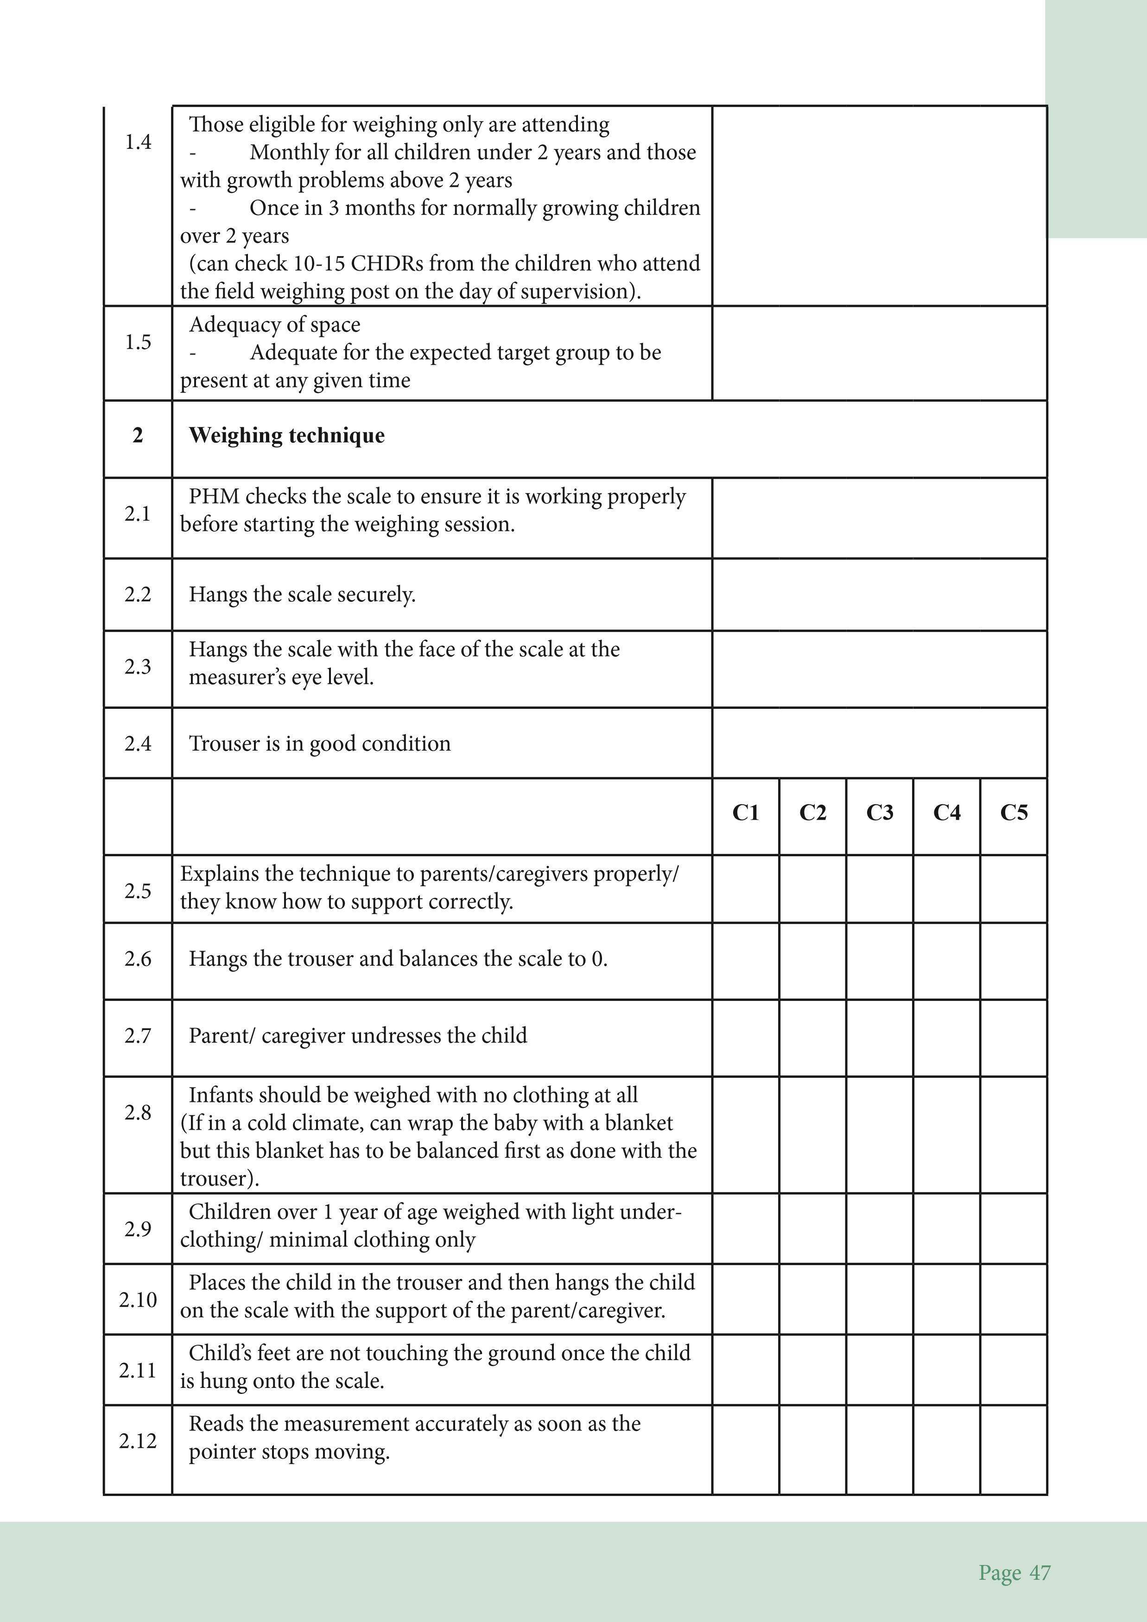

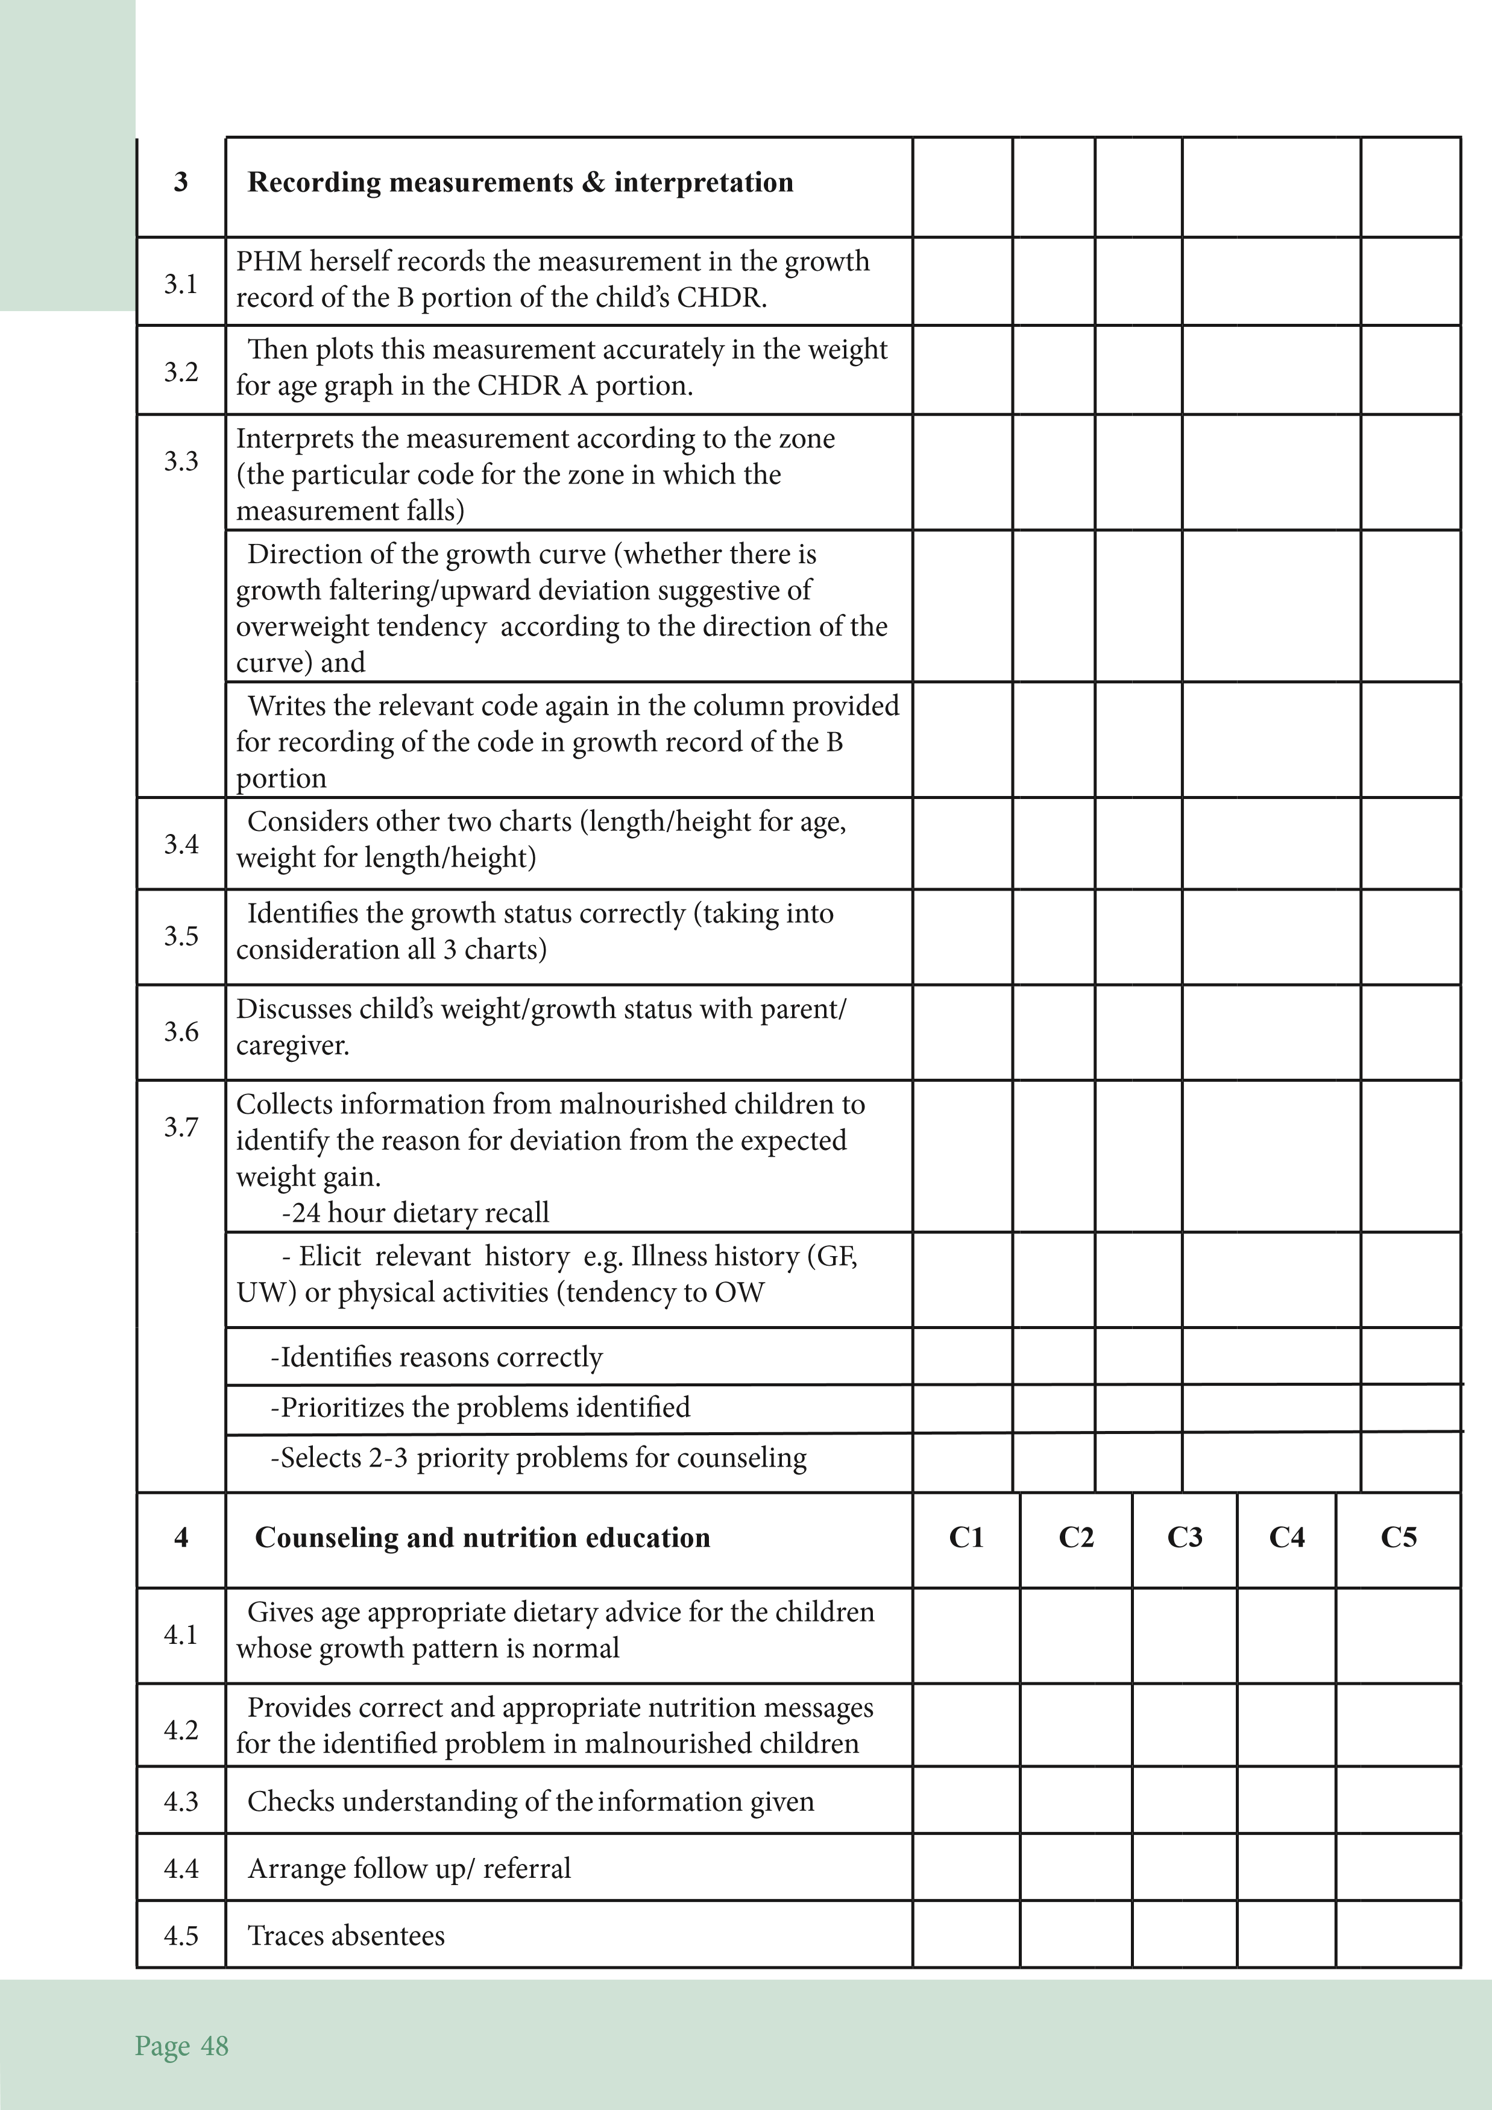

Page

49

4.6

Displays good counseling skills (listening and learning

skills and building confidence skills)

4.7

PHM has a plan for health education at weighing post

4.8

Individual counseling done at the weighing post

4.9

Targeted group education is being done

e.g.:-

Parents/caregivers are given appointments to attend

CF classes regularly. Age group wise for normal

children in older age groups (as per requirements

of the characteristics of children attending the

weighing post)

**5**

**Additional points**

5.1

Has support of volunteers to perform supportive work

in organizing the weighing post